**Spring Versions**

* Spring 2.5 – Annotations Driven Configuration
* Spring 3.0 – Supported all Java 5(Generics, variable arguments, new for loop)
* Spring 4.0 – Supported all Java 8 features(Functional Programming, Lambda Expressions)
  + - Web socket Based Communication. This is one step over Ajax
    - @RestController Annotation
    - @JmsListener Annotation – easily register listener endpoints
    - Jcache Annotation
    - More support for Json
* Spring 5 – Reactive Programming model, Fuunctional programming with Kotlin, minimum java 8 version, core container updates, Junit Jupiter 5 support for testing

**Course Name : Spring Fundamentals in pluralsight**

* Spring is a framework built to reduce the complexities around enterprise Java Development and later enterprise development without using EJBs
* Spring can be used with or without EJBs
* Its very light weight and until it came into existence, enterprise development was done using App Server. Now using Spring Enterprise development is done using light weight container like Tomcat
* POJO based : Any code written using Spring can be written only using java. Main purpose of spring is to use a cleaner and lightweight code.
* Framework uses best practices. It uses a template method pattern a lot.
* In Spring core, you have 2 types of scopes, singleton & protype. By default, it uses singleton scope for object creation. Whenever spring context gets created, it creates the object for the bean(who has @component annotation) and places it in the spring container. Whenever you request the object(eg getBean()), the object will be injected to your application. But in case you specify the scope as prototype, the bean object will be created for each request.

What problem does Spring try to solve?

It increases testability, maintainability, scalability and it decouples the code so that we can add caching without actually disturbing the actual code, it reduces the complexity of the code.It focuses mainly on business

What does Spring do behind the scene?

Everything in Spring is a POJO. It can be thought as a glorified hashmap. All the beans are stored in a container. Whenever we try to access the beans, concept of hashmap comes into picture.

Sample Application set up:

1. Create a maven project and fix the pom.xml to refer to the correct compiler version
2. Create model class, respository, respository impl class, service, service Impl class and Application class
3. Refer spring_sample project in workspace. Things are hardcoded.
4. To avoid hardcoding like creating instance of Impl classes directly etc, we go for spring.
5. To bring in spring, go to spring.io, click projects 🡪 Spring Framework. You will see the latest release enclosed in <dependencies> tag that has to be added to pom.xml. That’s all you have to do to work with Spring

*Spring XML configuration : Refer Spring_Sample project[C:\Users\stkra\Documents\Spring\workspace_1]*

1. ApplicationContext.xml :
   1. As we already know, Spring is hashmap of objects. We define the hashmap of objects in this xml file.
   2. This can be simply a registry file
   3. You can add namespaces here to help us with the configuration/validation
   4. Right click on src/main/resources and select new 🡪Spring Bean Configuration File
2. Seperation of Concern : We can change configurations without recompiling the code again, we could switch from environments like dev to test by using a different configuration file and not to recompile our application
3. Dependency Injection : Injecting the bean’s object that was created when the spring context was created into application during a request(eg: getBean()).
4. Setter Injection : Setter-based DI is accomplished by the container calling setter methods on the beans after invoking a no-argument constructor or no-argument static factory method to instantiate your bean.
5. Constructor Injection : Constructor-based DI is accomplished when the container invokes a class constructor with a number of arguments, each representing a dependency on the other class.
6. Autowire : Searching for the objects in the spring container by mapping it By name, type, constructor & No.
   * 1. By Name : Spring container looks at the properties of the beans on which autowire attribute is set to byName in the XML configuration file. It then tries to match and wire its properties with the beans defined by the same names in the configuration file.



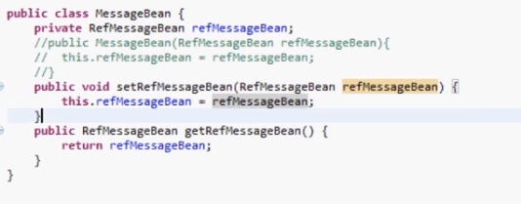

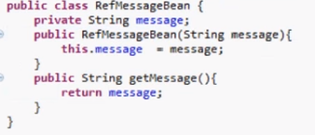

* + 1. By Type : Spring container looks at the properties of the beans on which autowire attribute is set to byType in the XML configuration file. It then tries to match and wire a property if its type matches with exactly one of the beans type in configuration file. If more than one such beans exists, a fatal exception is thrown.



* + 1. Constructor : Similar to byType, but type applies to constructor arguments. If there is not exactly one bean of the constructor argument type in the container, a fatal error is raised.

For example, if a bean definition is set to autowire by constructor in configuration file, and it has a constructor with one of the arguments as RefMessageBean(Type), Spring looks for a bean Type RefMessageBean, and uses it to set the constructor's argument.



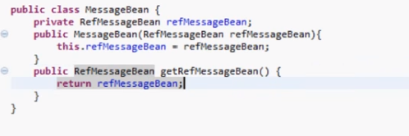



* + 1. No: This is default setting which means no autowiring and you should use explicit bean reference for wiring.
    2. Autodetect: Spring first tries to wire using autowire by constructor, if it does not work, Spring tries to autowire by byType.

*Spring Annotation Configuration using xml – Refer spring_sample_xml_anno*

Component Scanner : Spring will use component scanner to look for stereotype annotations and autowired annotations and wire up the application appropriately.To start with component scanner annotation, we need to do couple of things in applicationContext.xml

1. Context name space & the xsd in xml file by going to namespace tab
2. <context:annotation-config /> : To tell container that annotation is being used
3. <context:component-scan base-package="com.pluralsight" /> : Inform the container where to start looking for annotation

Stereotype Annotations: 3 types. They are semantically the same

1. @component : any pojo – This will tell the container to create objects for a class when the context is created and these objects will be available in the container
2. @service : extends @component. At Business Layer
3. @repository : extends @component. At data layer

Autowiring : member variable, constructor & setter methods

*Spring Configuration using Java – Refer spring_sample_java*

applicationContext.xml is replaced by AppConfig.java. To make the AppConfig a configuration java file, following has to be done.

1. Add @Configuration to this java file. The annotation basically means the java file is going to replace applicationContext.xml. @Configuration is at class level
2. Add @Bean at method level. Spring Beans defined by @Bean
3. @ComponentScan(“”) – This will be in the app config java. This means you have to check for Autowiring Annotation from the package present in the curly braces

*Bean Scopes- 5*

Valid in any configuration

1. Singleton(Default) – One instance per spring container

Java File : @Scope(ConfigurableBeanFactory.***SCOPE_SINGLETON***)

Xml File : <bean name=*"customerService"* class=*"com.pluralsight.service.CustomerServiceImpl"* autowire=*"byType"* scope=*"singleton"*>

1. Prototype – Unique instance per request. Each time, you request a bean, it guarantees unique instance

XmlFile : <bean name=*"customerService"* class=*"com.pluralsight.service.CustomerServiceImpl"* autowire=*"byType"* scope=*"prototype"*>

Java File : @Scope(ConfigurableBeanFactory.***SCOPE_PROTOTYPE***)

Valid only in web aware spring projects

1. Request – Bean per HTTP request
2. Session – Bean per Session
3. Global Session- single Bean per Application

*Properties*

XML Config : Refer spring_sample_xml

To load a properties file, we need to place the property place holder in xml file. Behind the scenes, this creates a property place holder configurer that is loaded from location attribute.

Check “context” from namespaces in xml file and then add the following to the xml,

<context:property-placeholder location=*"app.properties"* />

To use the properties in xml file,

<property name=*"dbUsername"* value=*"${dbUsername}"*></property>

To use the properties in java file using annotations,

@Value("${dbUsername}")

private String dbUsername;

Java Config : Refer spring_sample_java

@PropertySource("app.properties")//This will tell the container to load the properties file

// To make the properties available for the container. Creates an instance of the bean and store the values from the property file and makes it available for the context

@Bean

**public** **static** PropertySourcesPlaceholderConfigurer getPropertySourcesPlaceHolderConfigurer() {

**return** **new** PropertySourcesPlaceholderConfigurer();

}

//Access the properties

@Value("${dbUserName}")

GIT Repository : https://github.com/RaajeeKumar/Spring-Fundamentals-Code.git

**Course Name : Introduction to Spring MVC – Plural sight**

Which framework to choose?

1. Struts
2. Tapestry – governed by one person. Heavily object oriented and POJO based framework
3. Apache Wicket – Light weight framework, easier to configure
4. GWT – Rich user exp framework
5. JSF from Oracle- Rich user experience
6. Seam is a JSF framework from Jboss group
7. Stripes – light weight framework
8. Spring MVC – Light weight, heavy duty framework

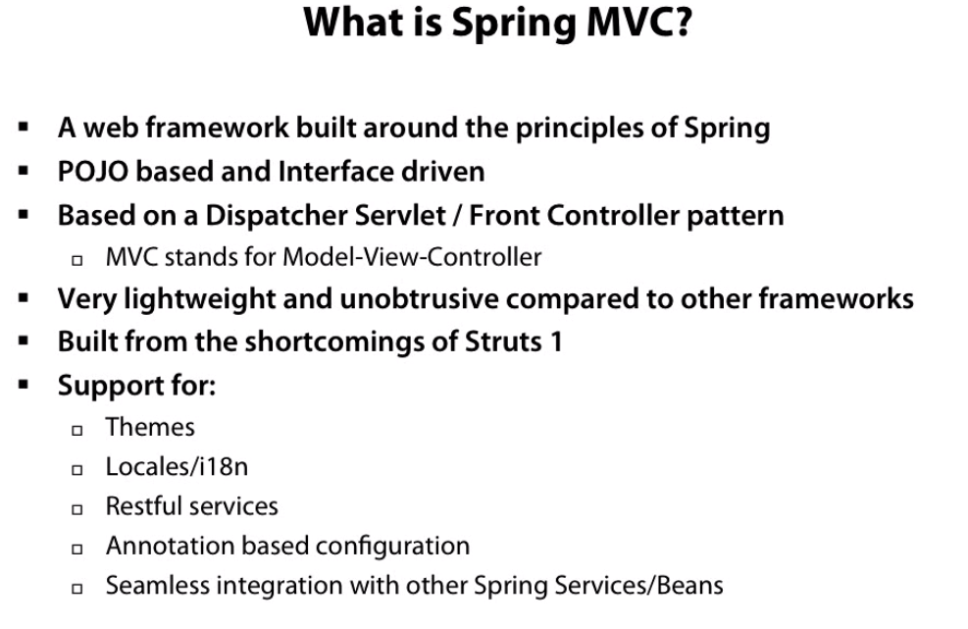

Lightweight means you don’t want to use all part of spring. For eg, you can use Spring JDBC without Spring MVC

Architecture : Java Servlets/Servlets API are on the bottom of the stack, Spring MVC is built on top of those technologies. They are just servlets but got some design patterns wrapped around them. We write custom app on top of Spring MVC.

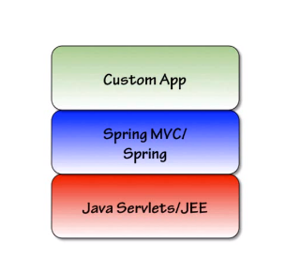

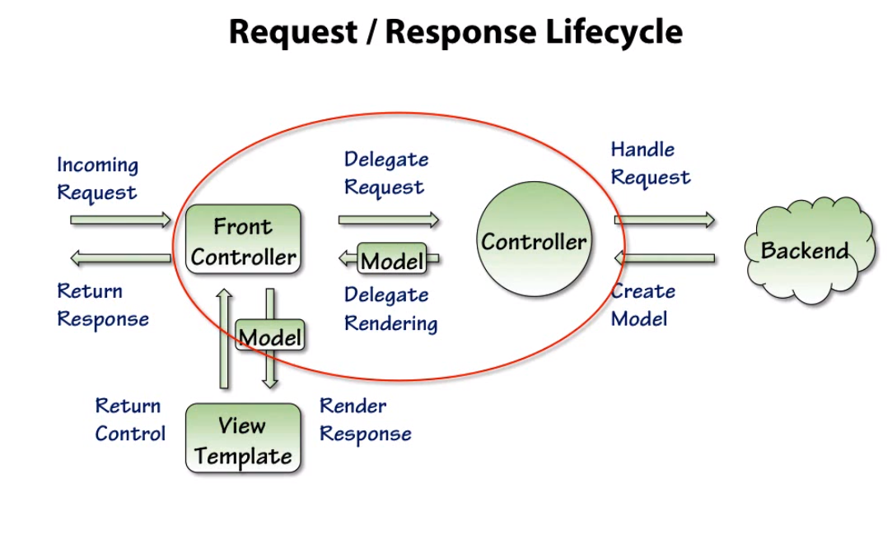

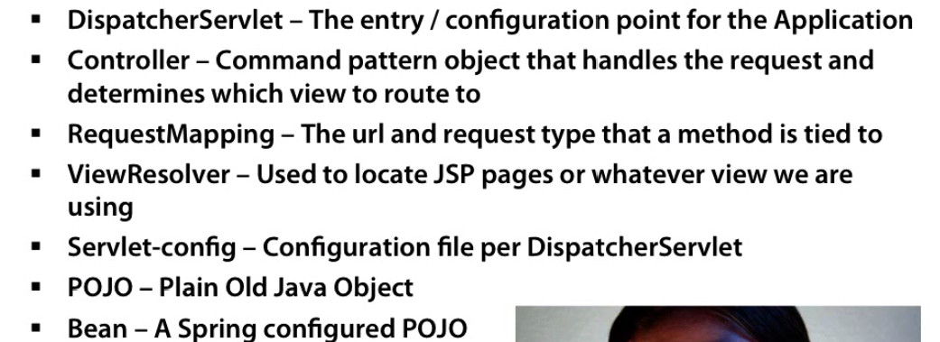

*Spring source Downloads if maven is not used:*

<http://projects.spring.io/spring-framework/>

Cant download web resources. 21 different jars will be downloaded

*Spring source downloads if maven is used:*

Three dependencies: spring-webmvc, servlet-api, jstl

Servlet-api & jstl are not actually needed. They are provided by the tomcat itself. But we will actually add it as a dependency with provided(Don’t package it as a WAR file as tomcat already provides it) scope.

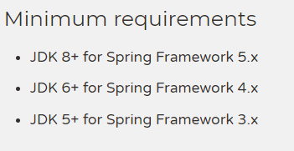

*Sample Application set up*

Pre-requisite : Java 1.8, maven 3.5, STS/eclipse, Tomcat 9, Spring MVC 4

1. Create a maven project in STS. There is no need to add any plugins to use maven if STS is used. If eclipse is used, you need to add m2 plugin
2. File 🡪 other 🡪 maven 🡪 Maven project. Accept defaults. Select an archetype as maven-archetype-webaspp. Provide the artifact id, groupid and hit finish
3. Add the following dependencies to pom.xml

<dependencies>

<dependency>

<groupId>junit</groupId>

<artifactId>junit</artifactId>

<version>3.8.1</version>

<scope>test</scope>

</dependency>

<dependency>

<groupId>org.springframework</groupId>

<artifactId>spring-webmvc</artifactId>

<version>4.3.7.RELEASE</version>

</dependency>

<!-- <dependency> <groupId>org.ow2.asm</groupId> <artifactId>asm</artifactId>

<version>5.0.3</version> </dependency> -->

<dependency>

<groupId>javax.servlet</groupId>

<artifactId>javax.servlet-api</artifactId>

<version>3.1.0</version>

<scope>provided</scope>

</dependency>

<dependency>

<groupId>javax.servlet</groupId>

<artifactId>jstl</artifactId>

<version>1.2</version>

<scope>provided</scope>

</dependency>

</dependencies>

1. Tomcat Setup :
   1. Open up the url, tomcat.apache.org
   2. Click the latest version under download on the left side. You will have to download the zip file under core section.
   3. Once downloaded, extract the file
   4. Add the new server by going to the server tab in STS
2. There are 4 parts that has to be configured
   1. Web.xml – Make sure the version is 3 at the top.
   2. Servlet-config.xml – Choose context, mvc, p namespaces and add entries for InternalResourceViewResolver
   3. Add controller
   4. Add View

Note: InternalResourceViewResolver – When a jsp page is requested, spring uses this class to find the jsp page in the directory and serve it

URL: <http://localhost:8080/FitnessTrackerApp/greeting.html>

Workspace Reference: C:\Users\stkra\Documents\Spring\mvc_workspace

**Controller:**

1. Gateway or proxy into a Spring MVC app
2. Annotations :
   1. @Controller : To inform Spring MVC that the class is a controller class
   2. @RequestMapping : At method level. The value here should match with the url specified by the user. Only then this method will be called
   3. @ModelAttribute : This is used when you want to send data to/retrieve data from the controller that is bound to an object or represented by an object
      1. **public** String addMinutes(@ModelAttribute("exercise") Exercise exercise) {

URL: <http://localhost:8080/FitnessTrackerApp/addMinutes.html>

Workspace Reference: C:\Users\stkra\Documents\Spring\mvc_workspace

**Views:**

View Resolvers

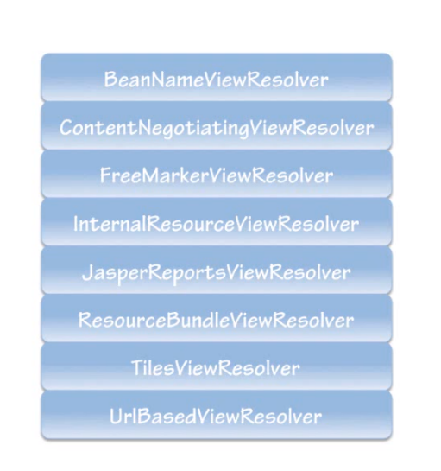

Chaining : forward(Current Request gets forwarded to the new page and the url doesn’t change in the browser), redirect(current request gets closed and new request is passed to the new page and url changes to the new one in the browser)

*Dynamically select views using InternalResourceViewResolver:*

<bean class=*"org.springframework.web.servlet.view.InternalResourceViewResolver"*

p:prefix=*"/WEB-INF/jsp/"* p:suffix=*".jsp"* p:order=*"2"* />

*Statically resolve files:*

Servlet-config.xml : <mvc:resources location=*"pdfs"* mapping=*"/pdfs/**"*></mvc:resources>

Web.xml : You have add entries to accept pdf here

URL: <http://localhost:8080/FitnessTrackerApp/pdfs/aadhar.pdf>

Workspace Reference: C:\Users\stkra\Documents\Spring\mvc_workspace

**Tag Libraries:** Spring MVC tag libraries are built on top of Java Standard Tag Libraries and they are included as part of Spring web jar

*Types:*

1. Spring.tld – Evaluating errors, setting themes and outputting internationalized messages
2. Spring-form.tld – For working with form data. Most of them are like html form tags, but have binding for working with backing object as well as validating its data

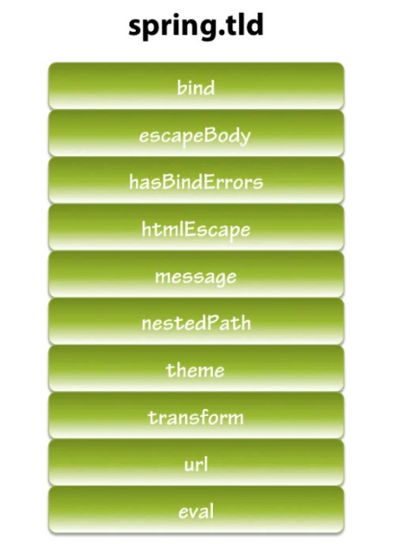

<bean id=*"messageSource"* class=*"org.springframework.context.support.ResourceBundleMessageSource"* p:basename=*"messages"*/>// This id will be referred by <spring:message> tag. Basename should match with the name of the properties file

Interceptors : To intercept an incoming request or outgoing response

<!-- Using Interceptor to display the page based on the language chosen -->

<mvc:interceptors>

<bean class=*"org.springframework.web.servlet.i18n.LocaleChangeInterceptor"*

p:paramName=*"language"*></bean>

</mvc:interceptors>// To intercept if there is a change in locale

<bean id=*"localeResolver"*

class=*"org.springframework.web.servlet.i18n.SessionLocaleResolver"*

p:defaultLocale=*"en"*></bean> // This will help choose the properties file based on the locale

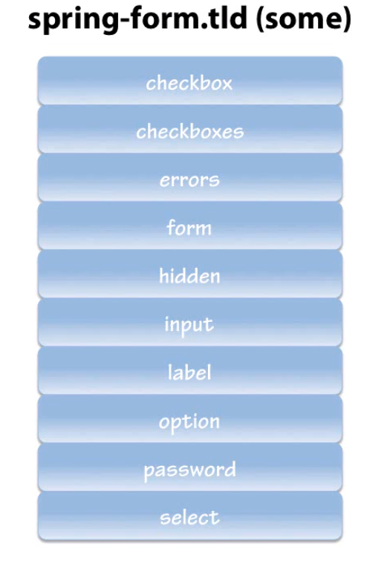

Validation:

1.Constraint Validation

2.Business Logic Validation

Two ways of handling validation in spring MVC:

1. Using validation interface and Validation Util Helper class
   1. You have to implement the validation interface and code all validation logic in this implementation class
   2. Validation Util classes will use Binding Result to do all the checks
   3. This type of validation can be done in Service tier outside of Spring MVC
2. JSR 303 :
   1. JSR is a specification that is established to do validation.Spring mvc integrates with JSR(Java standard) 303 for validation.Annotation Based and it can be used to built custom validation. This uses HibernateValidator.
   2. Include the following validation in pom.xml to import hibernate-validator and validation api jars for JSR 303 validation

<dependency>

<groupId>org.hibernate</groupId>

<artifactId>hibernate-validator</artifactId>

<version>4.2.0.Final</version>

</dependency>

* 1. Add the validation using the annotation range on the required field in the Object

@Range(min=1,max=120)

* 1. Make the following changes to the method in the controller,

@RequestMapping(value="addGoal", method=RequestMethod.***POST***)

**public** String getGoal(@Valid @ModelAttribute("goal") Goal goal,BindingResult result) {

System.***out***.println("Result has errors" + result.hasErrors());

**if**(result.hasErrors()) {

**return** "addGoal";

}

System.***out***.println("Goal set for today is" + goal.getMinutes());

**return** "redirect:addMinutes.html";

}

* 1. Following has to be added to jsp class,

<form:errors path=*"*"* cssClass=*"errorblock"* element=*"div"*/>

<td><form:input path=*"minutes"* cssErrorClass=*"error"*/></td>

<td><form:errors path=*"minutes"* cssClass=*"error"*/></td>

<style>

*.error* {

color: *#ff0000*;

}

*.errorblock* {

color: *#000*;

background-color: *#ffeeee*;

border: *3px solid #ff0000*;

padding: *8px*;

margin: *16 px*;

}

</style>

* 1. Following has to be added to properties ,

Range.goal.minutes= Goal must be between 1 and 120

URL: <http://localhost:8080/FitnessTrackerApp/addGoal.html> //Give negative value to check for validation

Workspace Reference: C:\Users\stkra\Documents\Spring\mvc_workspace

**Ajax**

*REST :*

* Built on top of HTTP. In Spring MVC, JSON can be returned using a different view resolver instead of using different framework or tools
* Verbs: CRUD stands for CREATE(POST), READ(GET),UPDATE(PUT),DELETE(DELETE)
* ContentNegotiatingViewResolver uses the Accept header that comes in the http headers to determine that it will host up. It can determine from the extension of the file that is sent.This can be used in conjunction with other resolvers but only thing is order has to specified. Always InternalResourceViewREsolver has to be called last.Additional JARs has to be added. JacksonJAR will be used to marshall our data to JSON

<!-- To use the content negotiating view resolver.Add this in pom.xml-->

<dependency>

<groupId>com.fasterxml.jackson.core</groupId>

<artifactId>jackson-databind</artifactId>

<version>2.7.5</version>

</dependency>

<dependency>

<groupId>com.thoughtworks.xstream</groupId>

<artifactId>xstream</artifactId>

<version>1.4.9</version>

</dependency>

<dependency>

<groupId>org.springframework</groupId>

<artifactId>spring-oxm</artifactId>

<version>4.3.7.RELEASE</version>

</dependency>

Following has to be specified in servlet config.xml

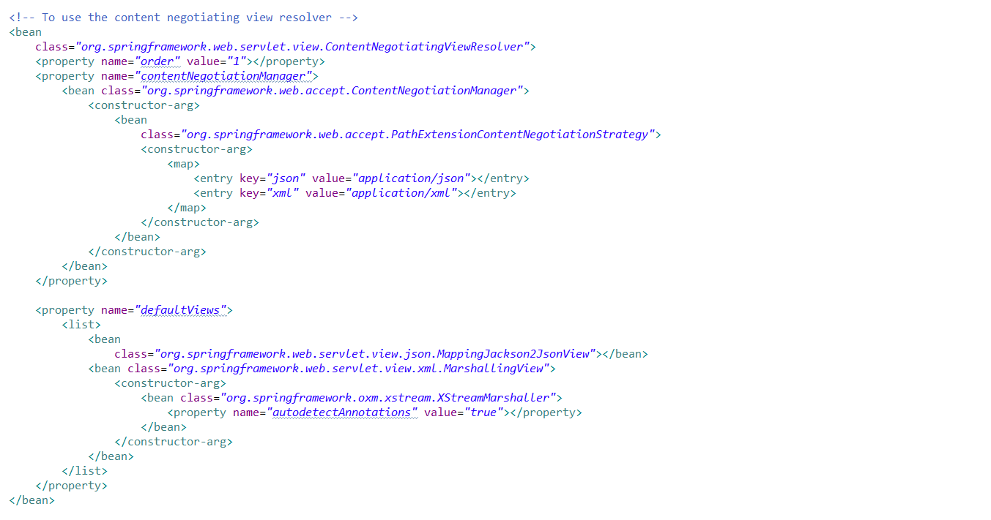

Web.xml : You have to add entries to accept json in web.xml

URL: <http://localhost:8080/FitnessTrackerApp/activities.json>

Workspace Reference: C:\Users\stkra\Documents\Spring\mvc_workspace

Jquery:

1. Download the latest version of jquery development version and drop it in src🡪 main 🡪webapp directory in STS

URL: <http://localhost:8080/FitnessTrackerApp/addGoal.html>

Workspace Reference: C:\Users\stkra\Documents\Spring\mvc_workspace

**Course Name : Introduction to Spring MVC 4– Plural sight**

To upgrade from Spring MVC 3 to Spring MVC 4,

1. Change the version of spring web-mvc & spring oxm jars from 3 to 4
2. *Point to be noted :* suppose I add a Spring-security-web.3.2.0.RELEASE jar to the pom.xml at the top, it will change all the transitive dependencies on web-mvc & oxm back to 3.2.0. So this means order always matter in the pom.xml. spring-security-web jar dependency has to be added to the bottom of the pom file inorder to retain the web mvc & oxm’s transitive dependency to be in version 4
3. File 🡪 New 🡪 other 🡪 Spring Boot 🡪 Spring Starter Project. Give all the values and choose the style “web” and then next and then finish. Spring Starter Project is a flavor of Spring Boot app
4. Create an index.jp under src🡪main🡪webapp
5. Delete Application.java & ApplicationTest.java
6. Create a new class named WebConfig.java. Add 2 annotations @Configuration & @EnableWebMvc. This annotation basically means we have created application-context and dispatcher servlet or servlet-config. This eliminated me create a web.xml and inside that create a listener and define a servlet, inside the servlet create mappings and everything else. Now when the application loads, it goes through and reads the classpath or anything with this annotation on it and automatically creates a context. @EnableWebMvc replaces servlet-config.xml
7. There is no need for web.xml in Spring 4. Servlet 3+ specification eliminates the need to create web.xml. But if you are using legacy app which uses servlet 2+, you can create the web.xml under src/main/webapp/WEB-INF folder.
8. Right click on the project name and choose Run As 🡪 Run on Server, you will get the index.jsp page.

*Spring 4 Architecture*

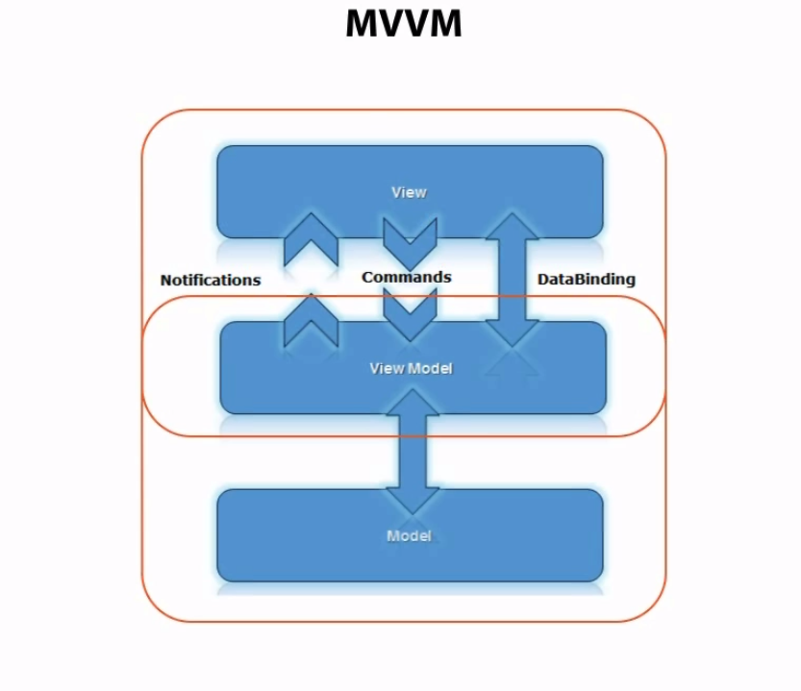

*Spring MVC 4 Controllers*

1. Controller is a verbs/actions that is performed on the model or noun on the system
2. Annotations:

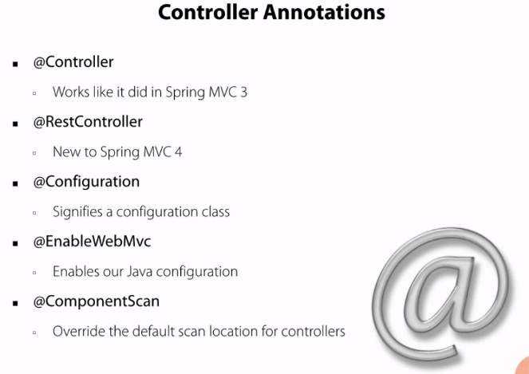

1. @EnableWebMvc : Only used for java configuration of Spring MVC web apps. Customizable by extending WebMvcConfigurerAdapter
2. @ComponentScan:

In xml : <context:component-scan base-package=””/>

In Java: @ComponentScan(basePackages = “”)

*Sample Project with web.xml:*

1. Created a controller, WebConfig.java(Configuration File), web.xml and then jsp file

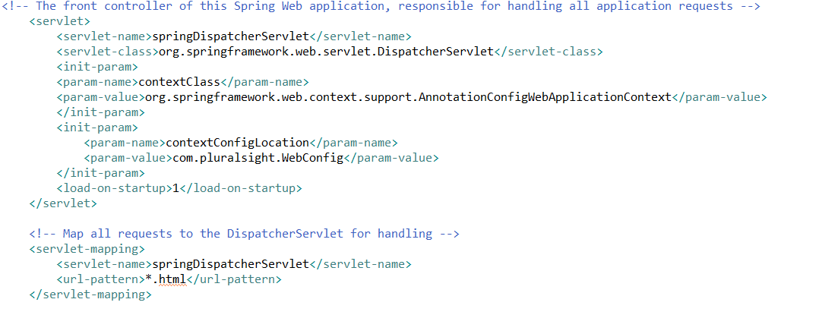

*Sample Project without web.xml:*

1. Comment out web.xml class or delete the WEB-INF directory
2. Create a WebAppInitializer java class.

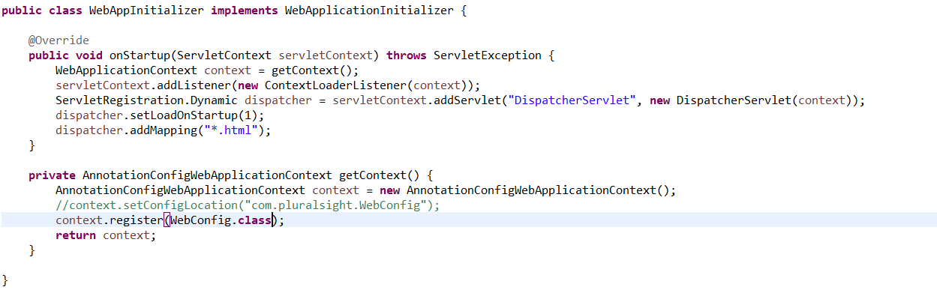

*Spring MVC 4 Views*

Internal Resource View Resolver using Java configuration : MVC container will autowire the bean based on its type and make it available internally during the start up process itself. This has to be given in WebConfig.java

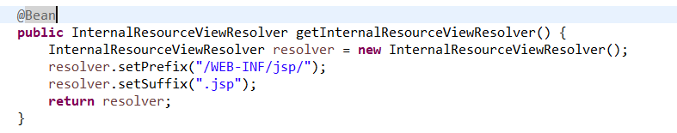

*Spring MVC 4 Build Out*

WebMvcConfigurerAdapter : Used to aid in configuration with our WebConfig. Helps replace items that were simplified with schemas in servlet-config.xml. Can be replaced with “extends WebMvcConfigurerAdapter”

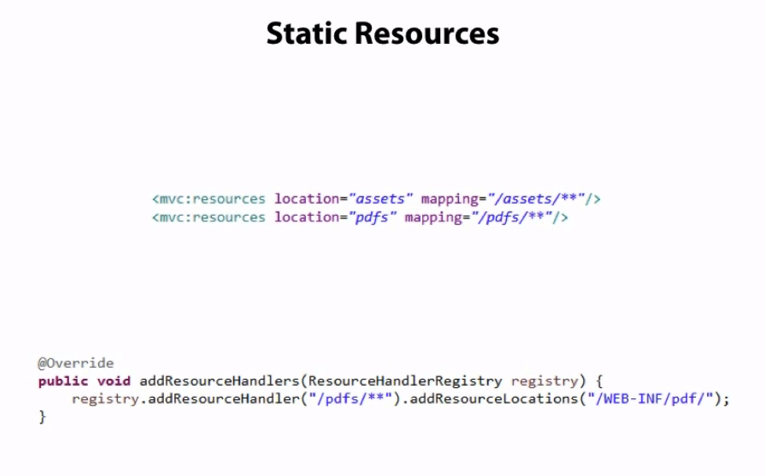

URL: <http://localhost:8080/EventTracker/pdfs/aadhar.pdf>

Workspace Reference: C:\Users\stkra\Documents\Spring\mvc_workspace

Internationalization: All these beans are autowired by name, so the method name should be correct.If not, there will not be any compilation errors. But the problem is, it will not work

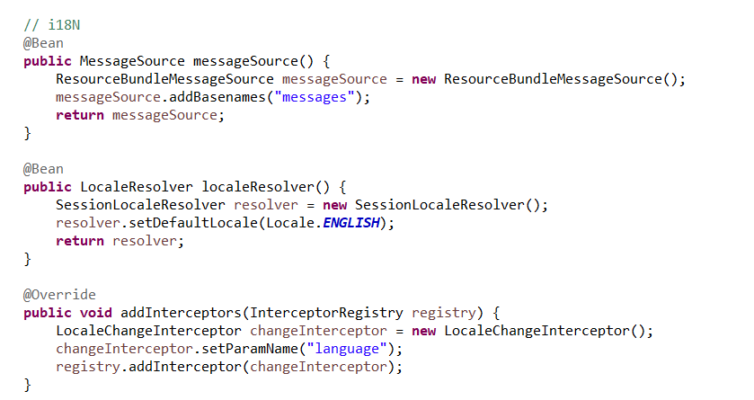

URL: <http://localhost:8080/EventTracker/>

Workspace Reference: C:\Users\stkra\Documents\Spring\mvc_workspace

*Spring MVC 4 Validation*

Following entries should be added in pom.xml

<dependency>

<groupId>javax.validation</groupId>

<artifactId>validation-api</artifactId>

<version>1.1.0.Final</version>

</dependency>

<dependency>

<groupId>org.hibernate</groupId>

<artifactId>hibernate-validator</artifactId>

<version>5.0.3.Final</version>

</dependency>

*Custom Validation*

Interface:

New🡪 Annotation

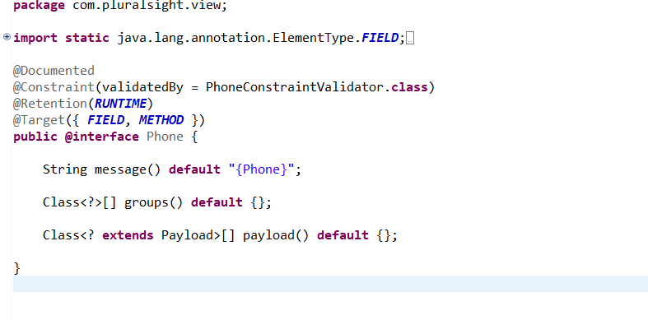

Implementation class:

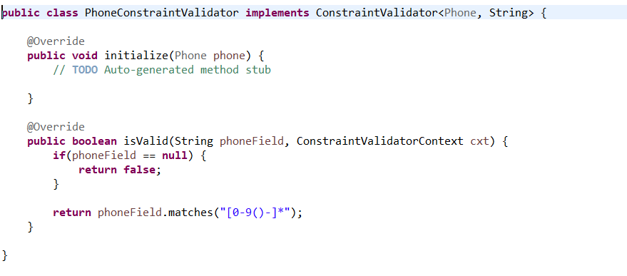

Model class:

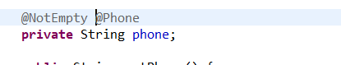

Jsp:

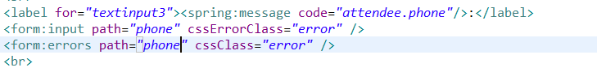

URL: <http://localhost:8080/EventTracker/>

Workspace Reference: C:\Users\stkra\Documents\Spring\mvc_workspace

*Spring MVC4 REST and Ajax*

@RestController :

1. Convenience annotation for annotating a controller and Response body at the same time
2. Assumes each RequestMapping is going to return the body of its request
3. No longer need to use the ContentNegotiatingViewResolver

webAppInitializer changes to get Json:

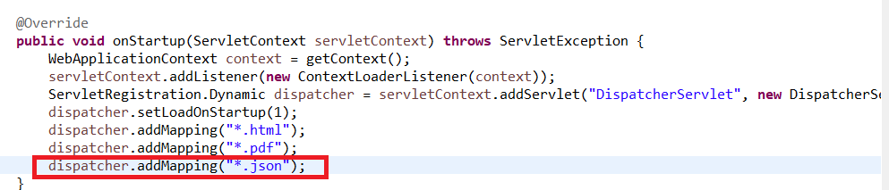

Controller :

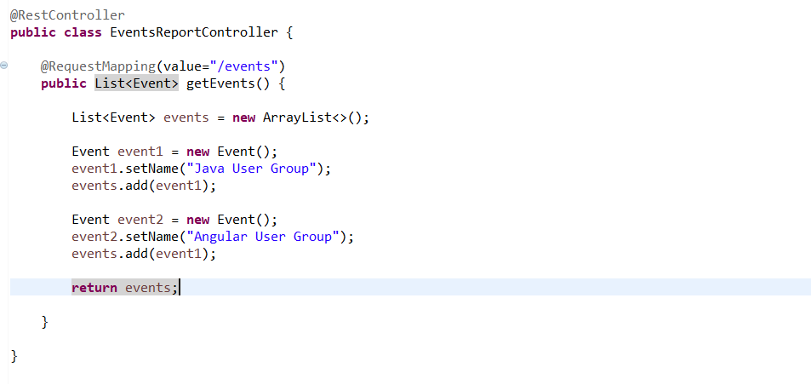

URL: <http://localhost:8080/EventTracker/events.json>

Workspace Reference: C:\Users\stkra\Documents\Spring\mvc_workspace

Angular Client

JS file

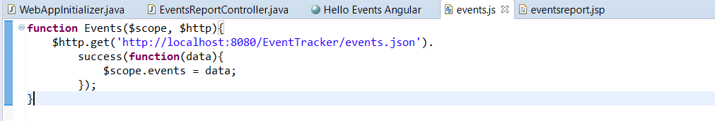

Jsp file

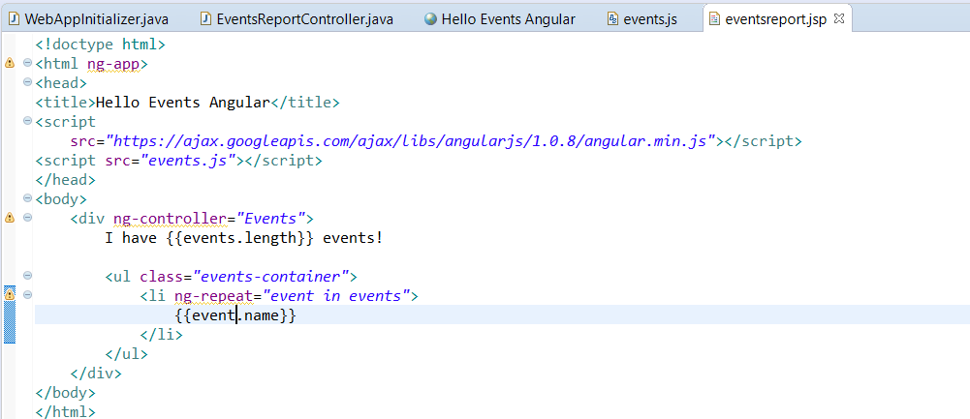

URL: <http://localhost:8080/EventTracker/eventsreport.jsp>

Workspace Reference: C:\Users\stkra\Documents\Spring\mvc_workspace

**Course Name : Spring with JPA and Hibernate**

JPA

Java Persistence API is focused on Object Relational Mapping or commonly referred to as ORM Design Principle. Originally it was part of EJB specification but was later extracted out just be available on its own

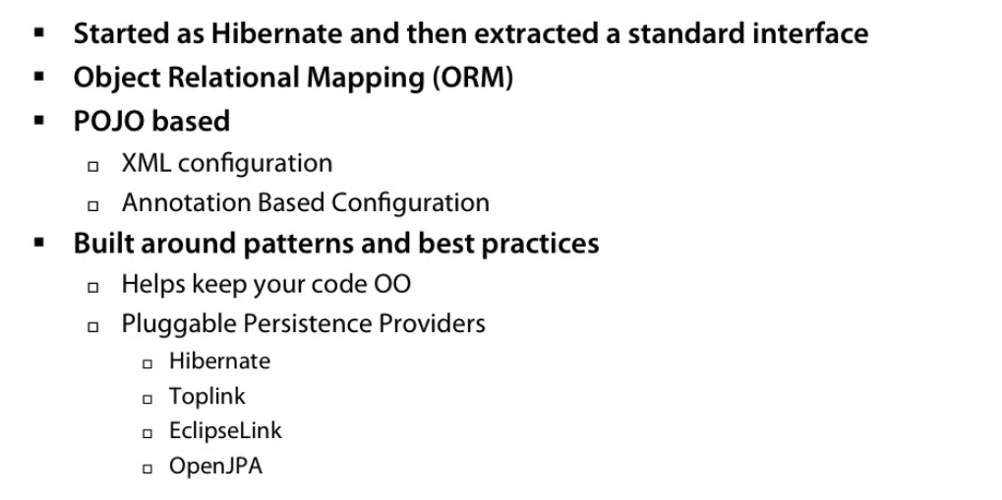

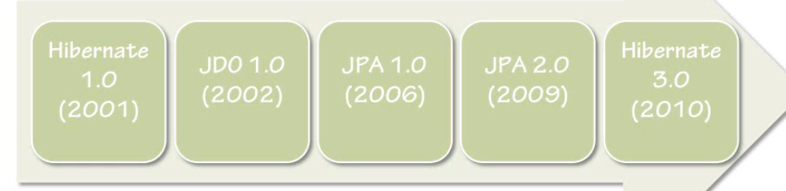

Problem :

1. Developers don’t always make good DBAs.

2. Data model don’t always line up with Object model

3. Configuration is better with JPA, but could be made still better

4. Business Focus

Solution:

1. Developers build object and JPA builds the gap. Transactions are transparent to developers. Annotation Based Development
2. Spring handles the better configuration
3. It removes boiler plate code and just focus on testing and business logic

Architecture:

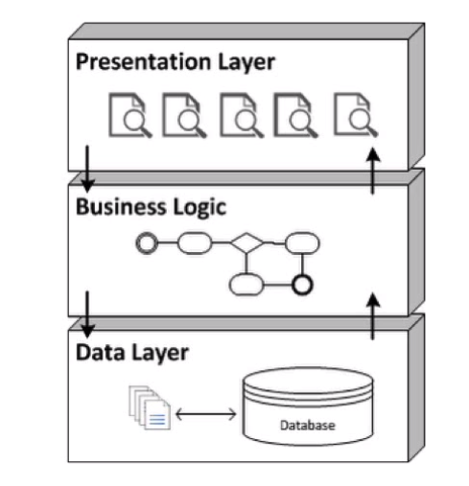

Spring and JPA configuration:

1. Go to dev.mysql.com/downloads and download the mysql-installer
2. Jars required for JPA : mysql-connector(connect to db), hibernate-entitymanager(actual provider of jpa),jta(implementing transactions),Spring-jdbc(libraries to get data source),spring-orm(to configure jpa within spring)
3. Persistence.xml – We define our persistence unit. Define datasource, allowed operations, caching. Here we can override settings per environment. It will be located under src/main/resources/META-INF/persistence.xml. This file has to be named exactly in the same way. Anything under this folder will be copied to classes in final war
4. jpaContext.xml – Used in place of persistence.xml and spring will load this class for us. This file need not be named in the same way like this. This should be placed under src/main/resources/jpaContext.xml. Contains the Entity Manager Factory(JPA Vendor, JPA properties), Transaction Manager, Annotation Configuration, Datasource Configuration or look up

File 🡪 New 🡪 SpringBeanConfigurationFile. Then add namespaces tx, beans, context.

<context:annotation-config />

<bean

class=*"org.springframework.orm.jpa.support.PersistenceAnnotationBeanPostProcessor"* />

Following piece of code has to be added in web.xml to load the jpaContext.xml. When the application starts, listener class is triggered by the container to start up the ContextLoaderListener.This class looks for contextConfigLocation which inturn looks in our class path for the file jpaContext.xml

<context-param>

<param-name>contextConfigLocation</param-name>

<param-value>classpath:/jpaContext.xml</param-value>

</context-param>

<listener>

<listener-class>org.springframework.web.context.ContextLoaderListener</listener-class>

</listener>

1. EntityManagerFactory :This is the place where we used to start to use JPA and Hibernate inside our application. This contains a class LocalContainerEntityManagerFactoryBean which resides in spring-orm.jar. we specify the jpa vendor and properties here.
2. Transaction Manager : JPATransactionManager takes the entityManagerFactory as a reference. It resides in spring-tx.jar. Annotation Driven
3. Datasource : DriverManagerDatasource that comes from spring-jdbc.jar

JPA and creating the first entity:

1. It is an interface for a specific implementation of an ORM. ORM bridges the gap between Oops and various relational dbs. This can be done using Annotations
2. JPA is an interface to ORM. Its not an actual implementation, we have lot of vendors like ORM do the actual implementation. ORM is a implementation of JPA.
3. JPA is a specification for accessing, persisting and managing data between java Objects and relational dbs.
4. It is not SQL, but writes sql under hood using JPQL(Java Persistence Query Language). It deals with POJOs and Java Objects.
5. Hibernate is one of the commonly used JPA providers
6. We can use Hibernate directly or JPA using Hibernate. Always use JPA using Hibernate so that if there is a need to switch between providers, it will be easy to do.
7. Entity : Adding @Entity and @Id to a simple POJO class tells JPA to use this class as an entity to be used with the db
8. *hibernate.hbm2dll.auto* Values : Create[creates the db], Createdrop[creates the db at the start of our app and drops it once done], update[Just updates the values without deleting anything], validate, none. In JPA 2.1, we can use the property *javax.persistence.schema-generation.database.action*

**JPA Annotations:**

Alternative way is to use hbm.xml or orm.xml file. But we are using annotations,

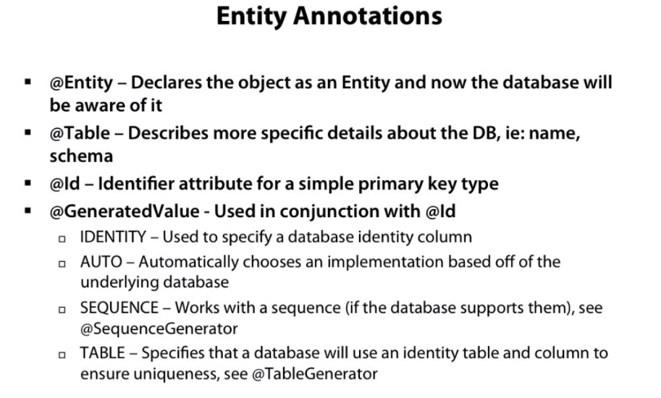

@PersistenceContext – Injecting the entity Manager in the code

@Transactional – To indicate the beginning of transaction

<context:component-scan> annotation should not be repeated in multiple configuration file with the same location.

URL: <http://localhost:8080/FitnessTracker/>

Workspace Reference: C:\Users\stkra\Documents\Spring\mvc_workspace

Project:FitnessTrackerJPA

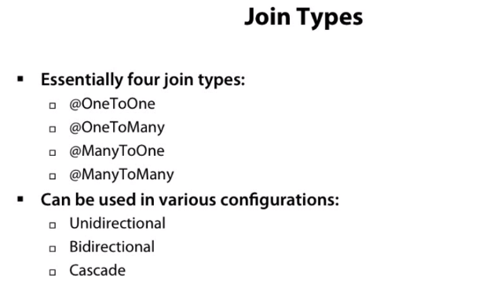

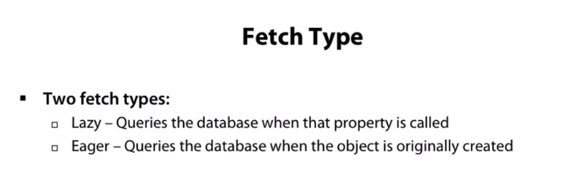

Lazy Initialization is used when we have composite data.

Resolving Lazy Initialization Exception:To resolve this exception add the entry for OpenEntityManagerInView Filter in web.xml

OpenEntityManagerInViewFilter : Used to increase the length of the JPA session. JPA session starts at the service tier and then repository tier is called and ends when we come back to our service tier.

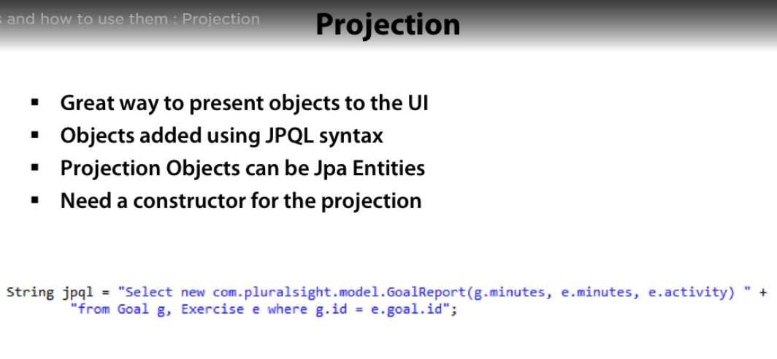

URL: <http://localhost:8080/FitnessTracker/goalReport.html>

NamedQueries

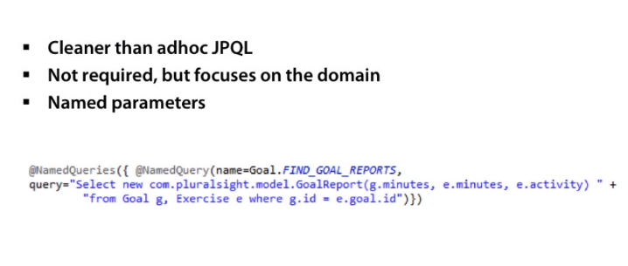

**Spring Data JPA**

Framework to eliminate boiler plate code with regards to the DAO layer

It replaces our repository tier unless you need custom functionality

Can be extended for additional functionality

Need to add the spring-data-jpa jar & spring-data-commons jar

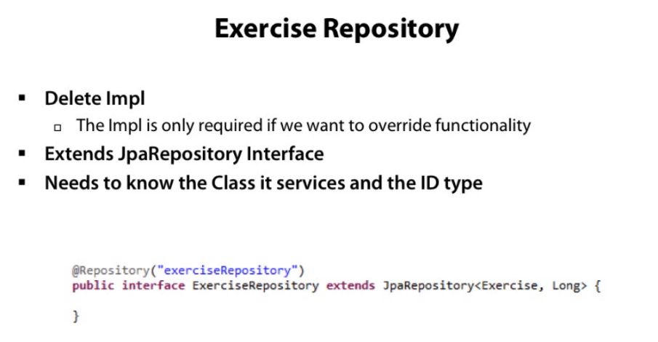

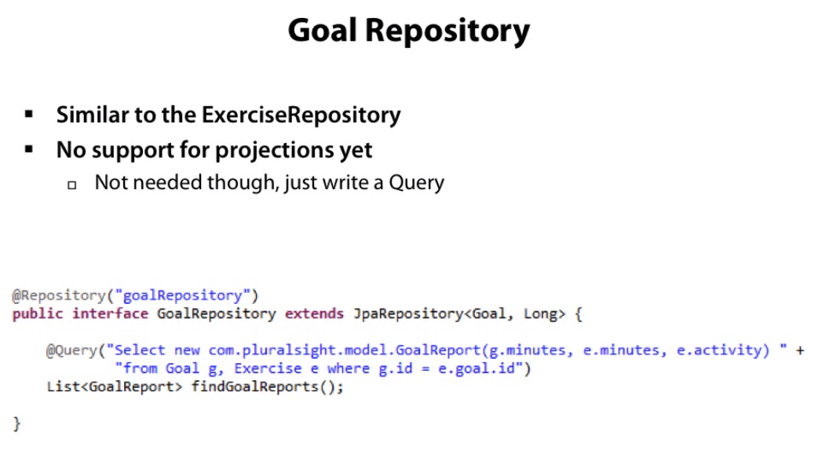

Behind the scenes, it uses AOP and basically makes a DSL in the back of it, to generate the code on the fly and it knows based off of your names what to do with that object

**Course Name : Spring Security Fundamentals in pluralsight**

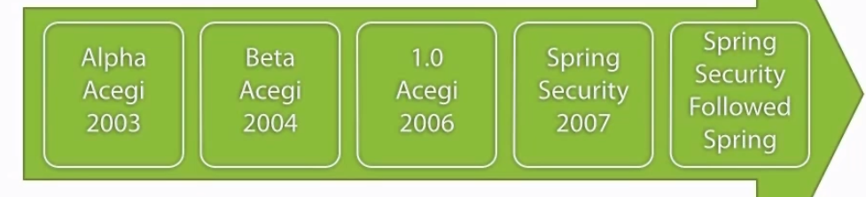

Authentication : Who am I? Normally its done using LDAP or Active Directory Server

Authorization: What can I do here? Authorization is followed by Authentication.

Maven Dependencies :

spring-security-web(All of our web enabled configuration for our framework),

spring-security-config(general security configuration),

commons-logging(façade for tying the underlying logging mechanism inside our application)

Bootstraping Spring Security:

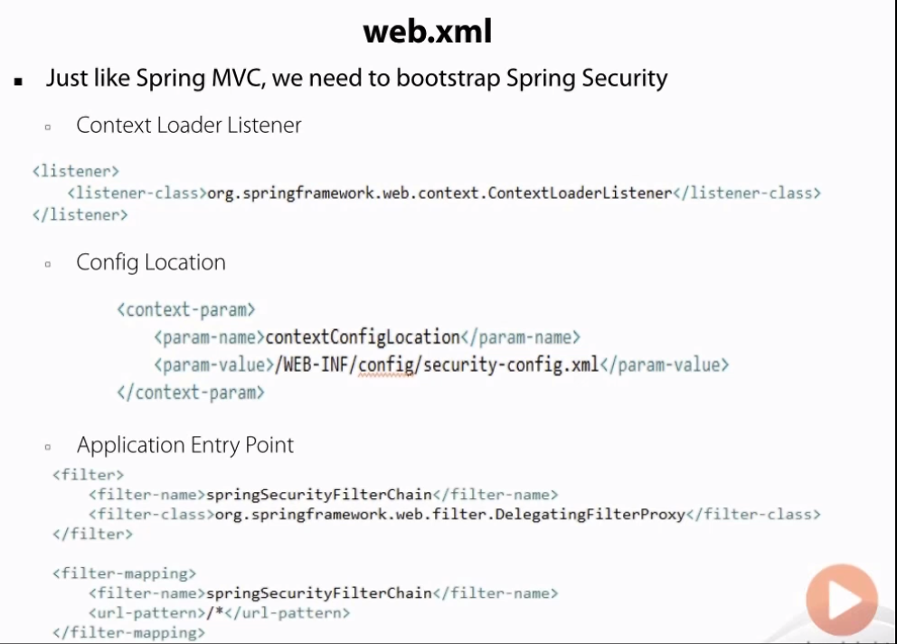

Security-config.xml :

Filter in web.xml has to point to something in the spring security configuration. The simplest configuration can be obtained using http tag. So the filter defined in web.xml gets tied into this http tag.

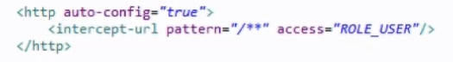

Every url must be accessed by somebody who has the role of ROLE_USER

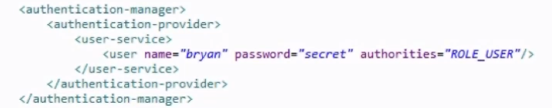

User Storage in Database:

Spring Security contains a JdbcDaoImpl that can be configured to any database. So certain features are available only when connected to a database. Created 2 tables users & authorities in mysql Database.

Maven jars to be added to connect to mysql db and to obtain datasource : mysql-connector-java, spring-jdbc

*Two ways of implementing Jdbc configuration:*

1. First way

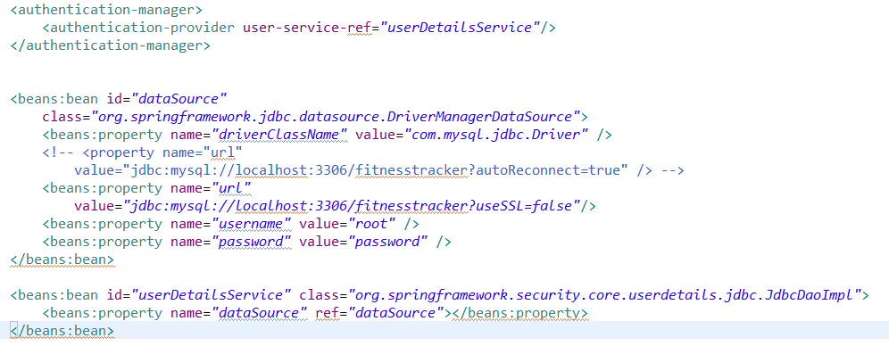

1. Second way

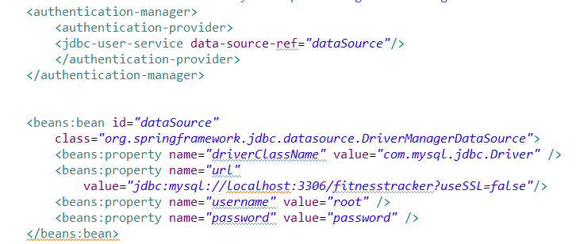

URL: <http://localhost:8080/FitnessTracker/>

Workspace Reference: C:\Users\stkra\Documents\Spring\mvc_workspace

Project:FitnessTrackerSecurity

Once we hit the above url, user will be getting a login page which is created by the configuration “auto-config=true” in <http> tag and <http:basic/> for getting the dialog box for entering the user namename and password. Also /** is called the ant pattern

Client Integration:

This can be simple as displaying who is logged in or as complex as determining who should be able to see certain sections of page. The can be implemented using spring security tag libraries.

<%@taglib prefix=”sec” uri=”http://www.springframework.org/security/tags”%> // Uri doesn’t download from the uri but rather it is just a key to look it up as it is contained within a JAR file

Three tags:

authorize – contents within the element should be evaluated or not

authentication – to gain access to the user object who is logged in

accesscontrollist – They are commonly referred to as ACLs. ACLs are used in rule based voting system.

Maven Dependency : spring-security-taglibs jar

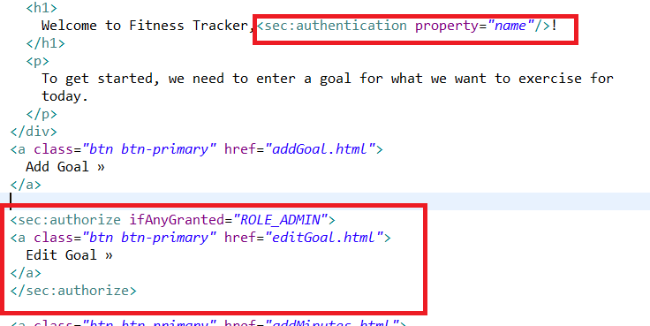

Password Storage:

MD5 Hash Technique for encrypting password – this is weak

Bcrypt Hash with a salt – Salt makes the passwords complex. Passwords are 60 characters in length

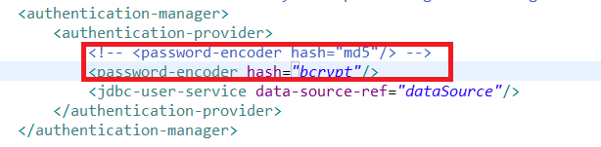

Customizing Spring security

*Basic Authentication:* A dialog box opens asking for the credentials. Configuration to be done in security-config.xml

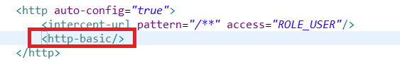

*Custom Login Form:*

Security-config.xml :

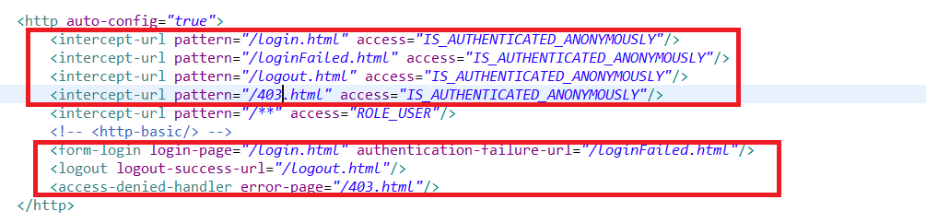

LoginController:

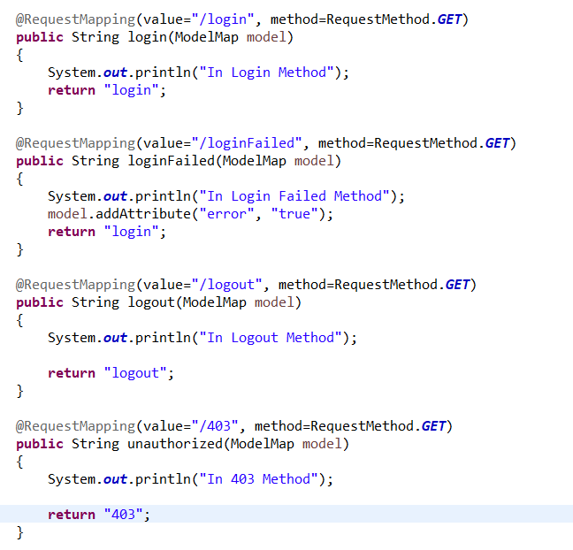

Then the respective jsp pages has to be created.

**Enabling security with Expressions:**

We can statically add values or write expressions.

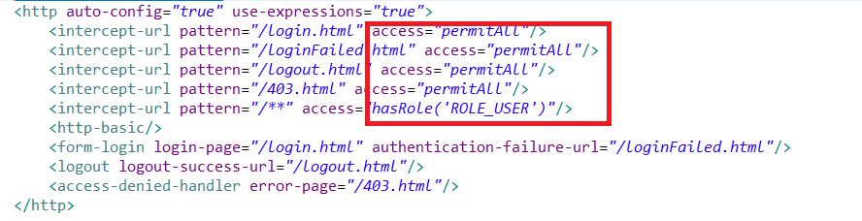

*Method level Security:*

To enable method level security, we have to add the tag <global-method-security>in the xml file . Following annotations can be used,

Pre-post-annotations

Secured-annotations

Jsr-250-annotations

Mvc context – loaded by dispatcher servlet. This is where all our controllers are defined and our view resolvers

Security context – This is where security is configured and datasource configuration for communicating with the database. This is loaded by the ContextLoaderListener class inside the web.xml.

Servlet-config.xml:

<security:global-method-security pre-post-annotations=*"enabled"*/>

In controller add the appropriate annotations

@PreAuthorize(“hasRole(‘ROLE_ADMIN’)”)

*Permission*

1. Goal Controller

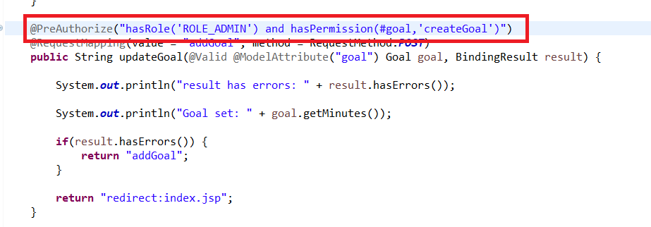

1. Create a Permissions table in Db and add a user to the table

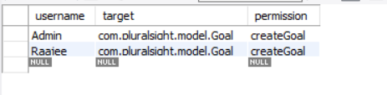

1. Create a handler class,

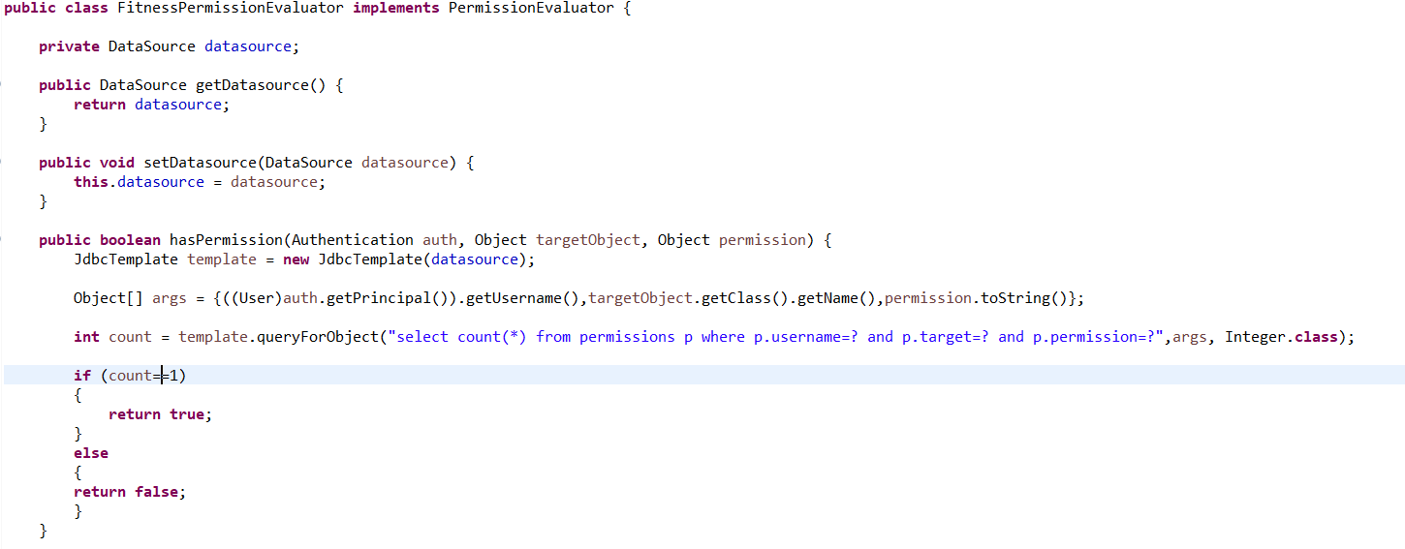

1. Servlet-config.xml

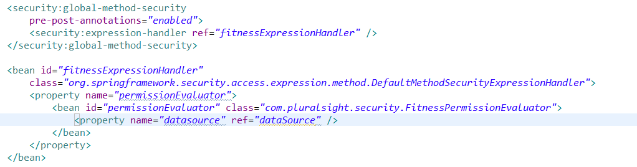

**LDAP Configuration**

Maven JARS

Slf4j-simple : logging built out of the LDAP JARS in the apache directory server we are importing in our application

Apacheds-all : This is simply our directory server that we are going to fire up inside the application.This will either connect to a LDAP server or will create a lightweight server inside our application

Spring-security-ldap : LDAP configuration inside our application

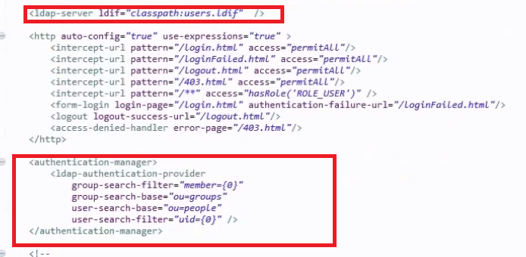

**HTTPS Configuration**

*Self signed Certificate Generation*

1. Open up command prompt and go to the current installation of tomcat C:\Program Files\dev\tools\tomcat\apache-tomcat-9.0.4\bin
2. Type the command, keytool -genkey -alias tomcat -keyalg RSA -keystore C:\Program Files\dev\tools\tomcat\apache-tomcat-9.0.4\bin\tomcat. This will create the keystore information.
3. Now we have to open up the server.xml under tomcat and uncomment the connector section and add keystorefile location and keystorepassword information

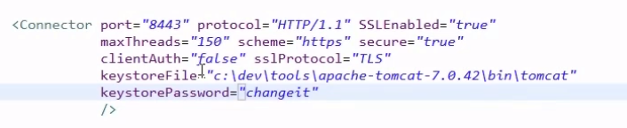

1. Then add attribute **requires-channel=”https”** in all intercept-url tag in security-config.xml
2. <http://localhost:8080/FitnessTracker/login.html> will be routed to <https://localhost:8443/FitnessTracker/login.html>

**Course Name : Getting started with Spring Data JPA**

**by Dan Bunker in pluralsight**

Spring Data JPA

1. Enhances Standard JPA(Java Persistence API) with Spring
2. Reduces code and simplifies the Data Access Layer
3. Repository Generator – Java Interfaces that allows us to develop a data access contract. Framework will inspect this contract to do actual implementation for us.
4. Query DSL – For the framework to intelligently to the implementation for us, Domain Specific Language is needed. It creates java interface methods that utilize keywords along with JPA Entity attributes to perform the work needed to correctly implement the queries.
5. Auditing and Paging
6. If in case, its not able to provide your project specific needs, it gets out of the way if needed.

Installing Spring Data JPA

Add the following to the pom file,

<dependency>

<groupId>org.springframework.data</groupId>

<artifactId>spring-data-jpa</artifactId>

<version>1.7.1.RELEASE</version>

</dependency>

Add the following to the application context xml file. Also add the xsd information on top

<jpa:repositories base-package=*"com.guitar.db.repository"* />

If you are not using xml configuration, you will have to add the appropriate annotations on top of the repository class,

@EnableJpaRepositories

Repository Architecture Overview

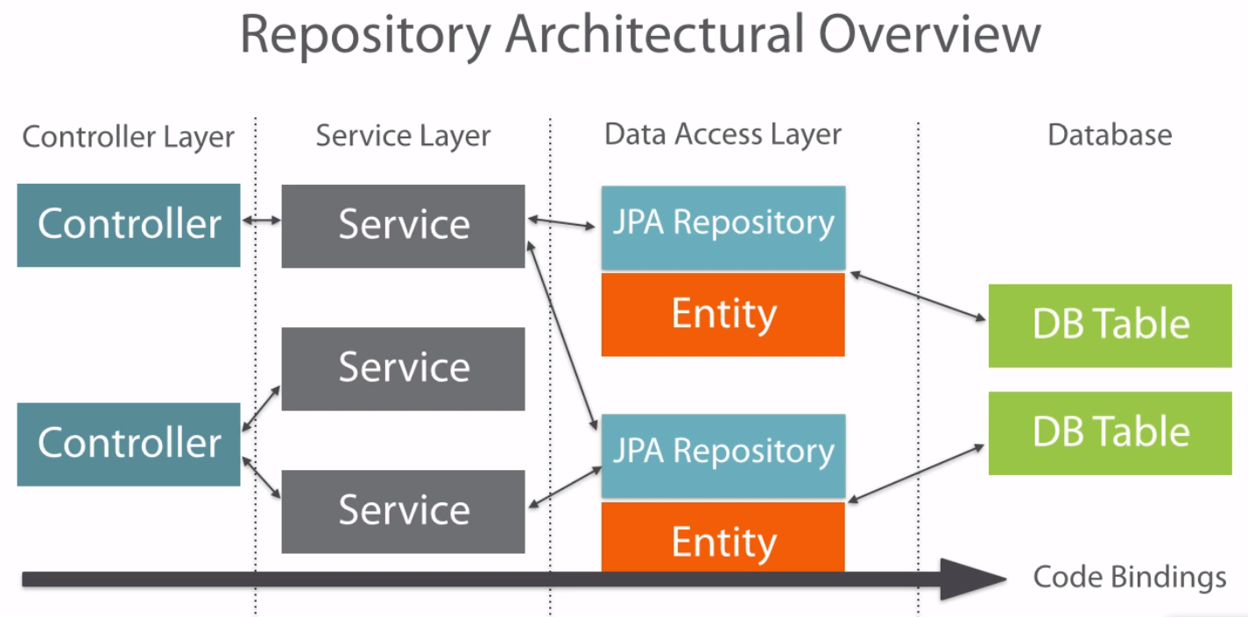

Difference between Spring Repositories and Spring Data JPA Repositories

Spring DataJPARepository :

1. Its an interface not a class.
2. One to One mapping. One Repository is mapped to one table in the DB. This is done through generics on the interface.

Public <RepositoryName> extends JpaRepository<EntityName, Datatype of the ID column>

1. Implementation details is hidden from us. This is based on the Repository you extended.

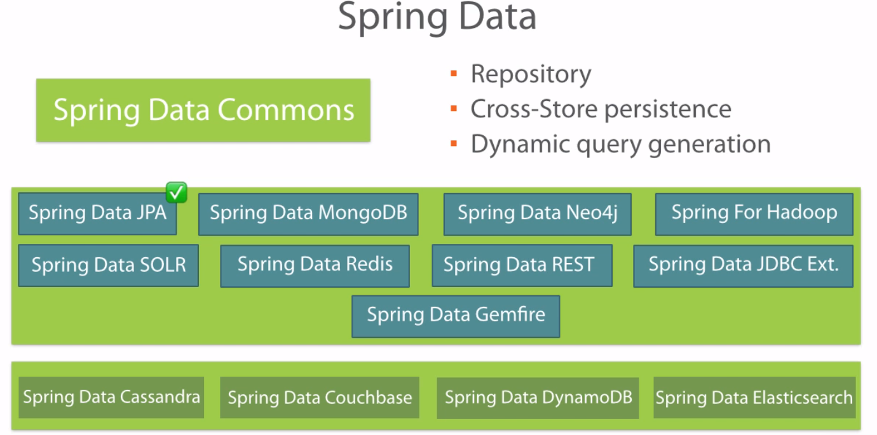

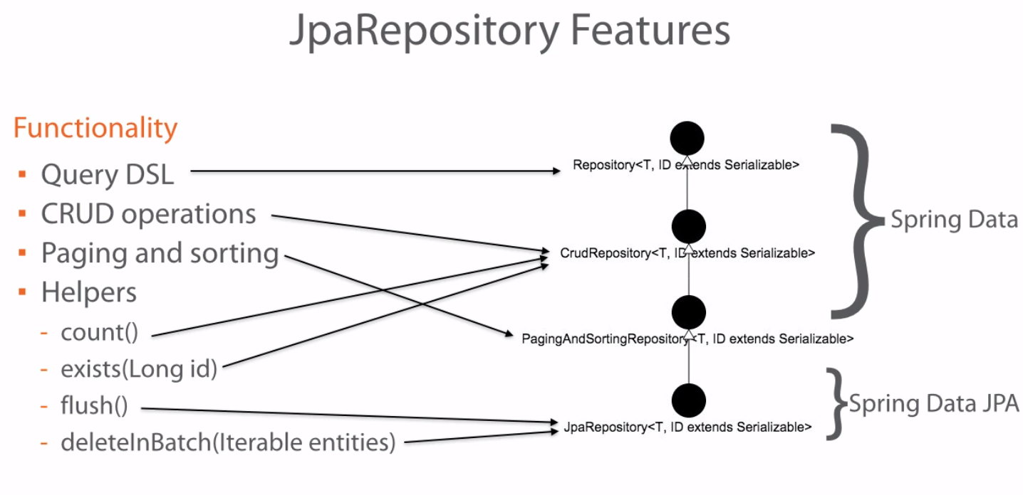

Query DSL or Query Methods

Domain Specific Language is a customized extension of a software programming language that addresses a specific domain or business.

*Advantages*

1. It writes the custom queries and finders.
2. Less code easy to maintain
3. Checks the queries at start up rather than run time

How does the Spring Data Jpa writes the queries automatically by looking at the method declaration in the interface? Using Query Methods. This is also known as Query DSL methods

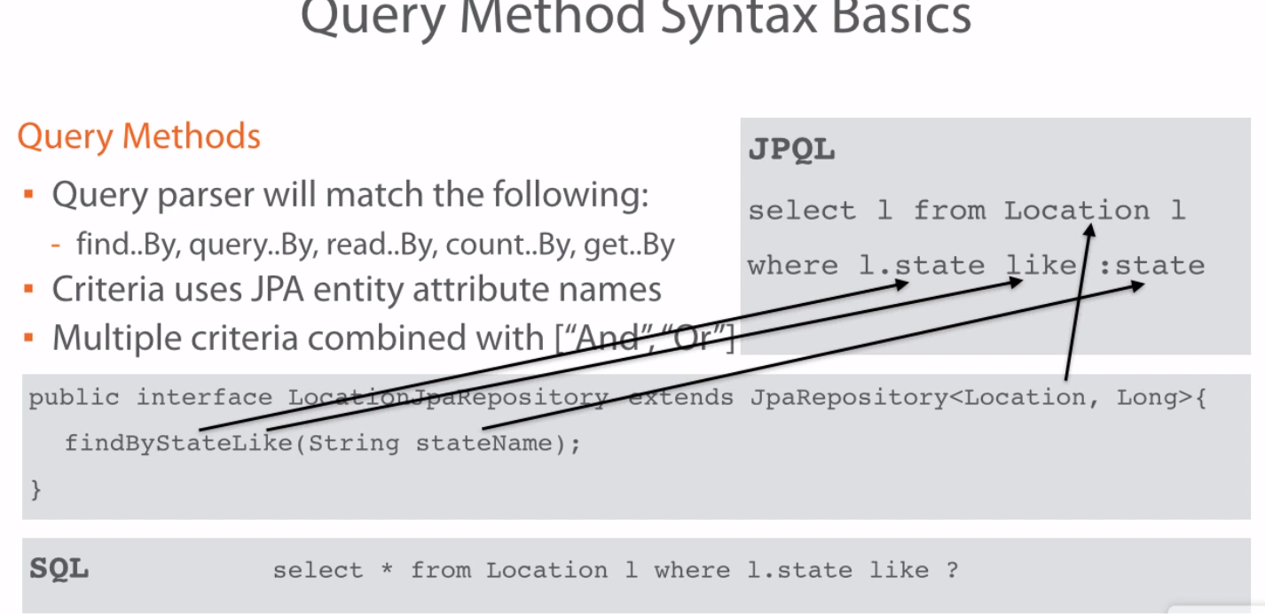

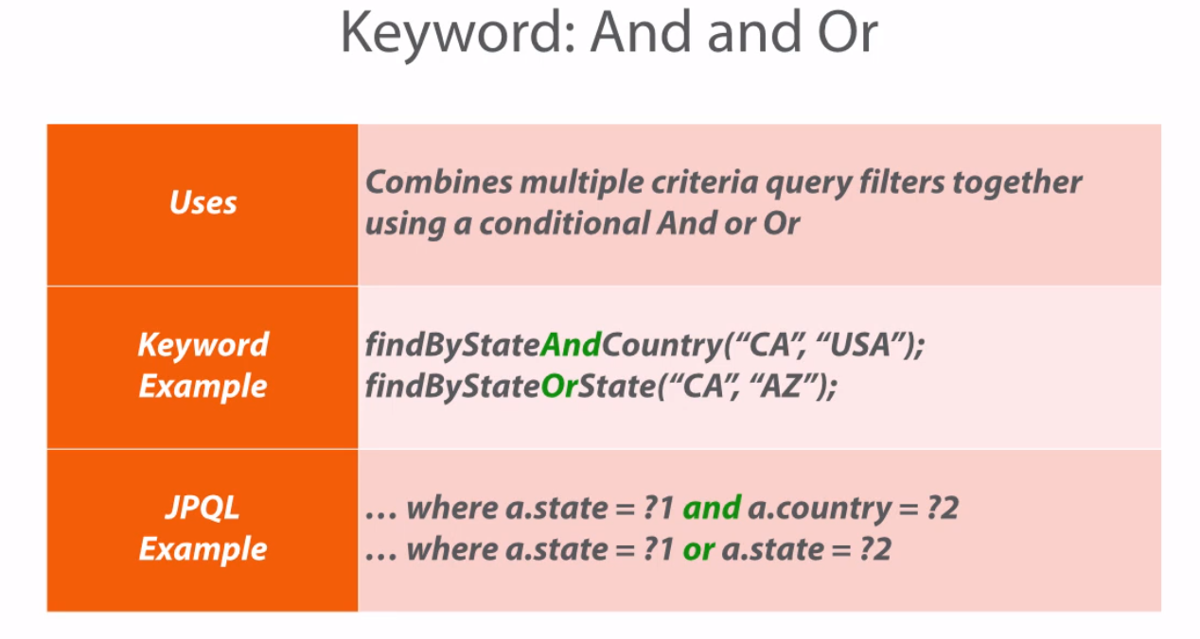

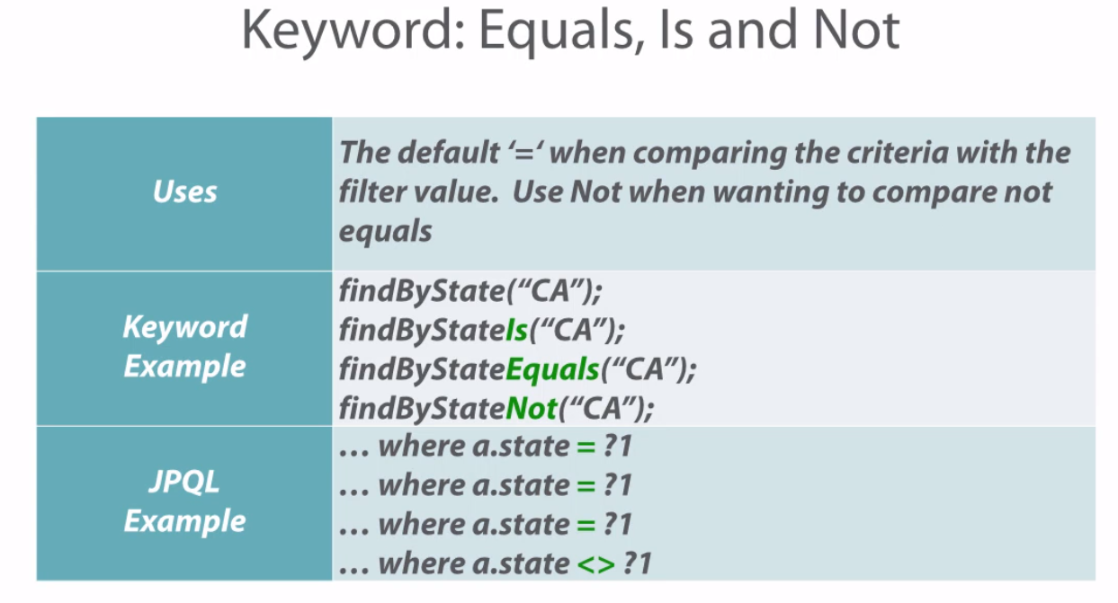

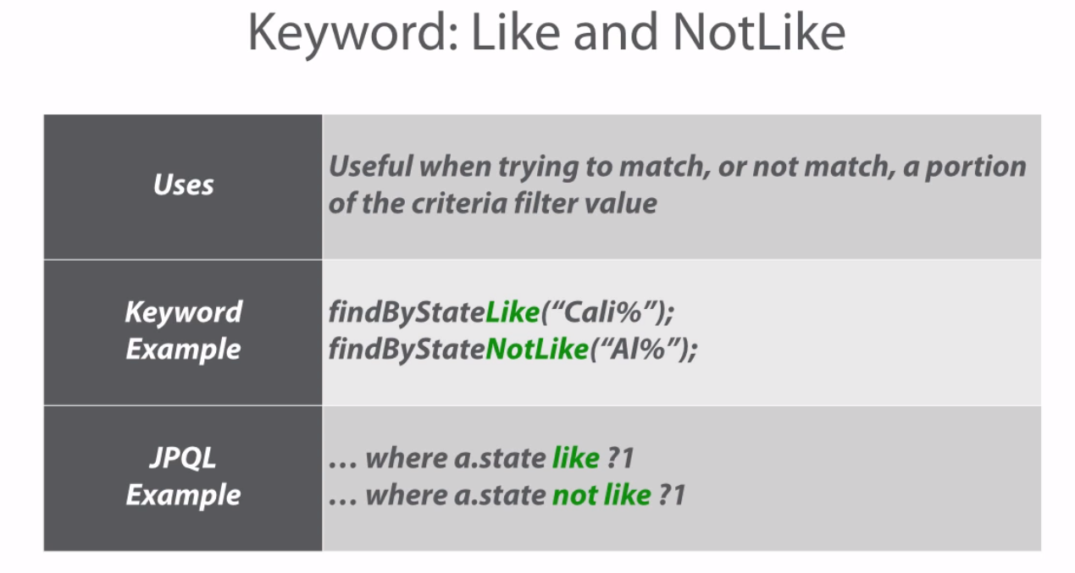

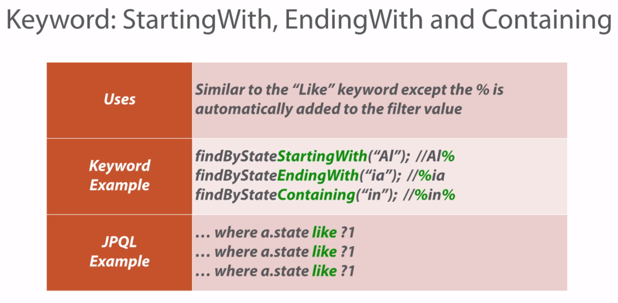

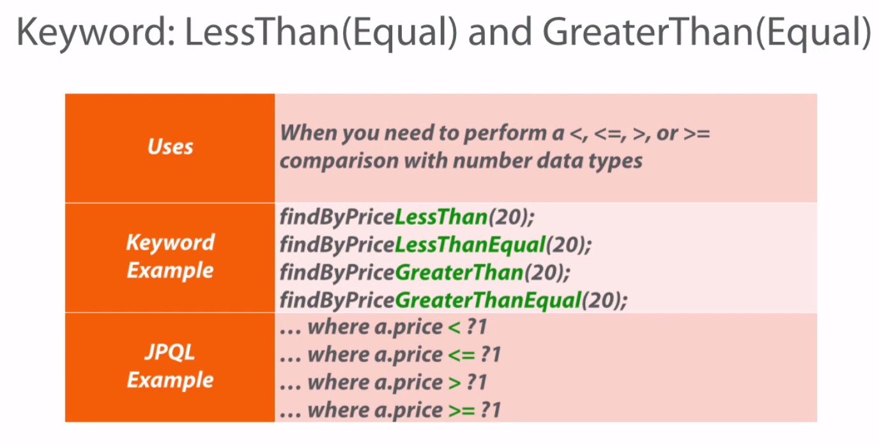

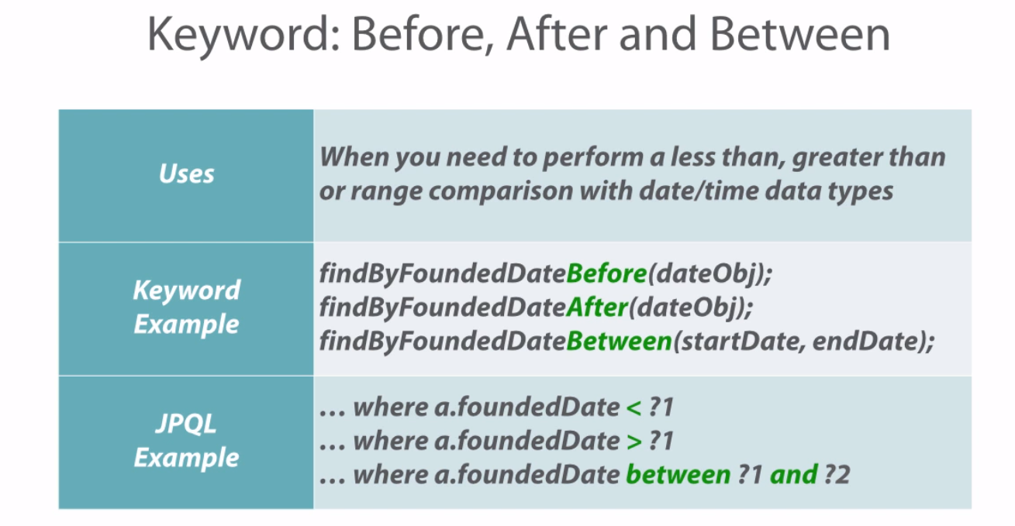

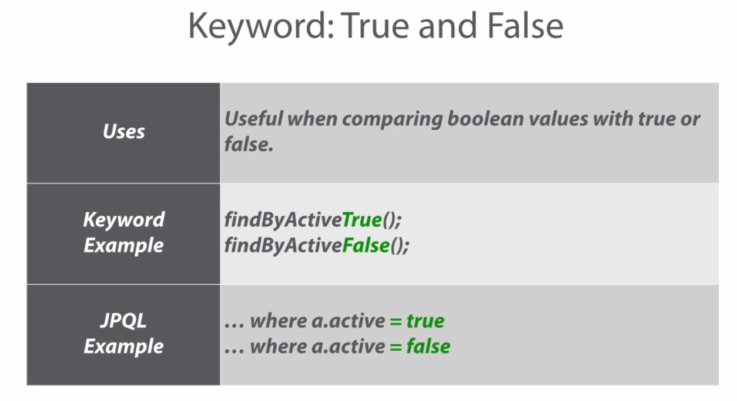

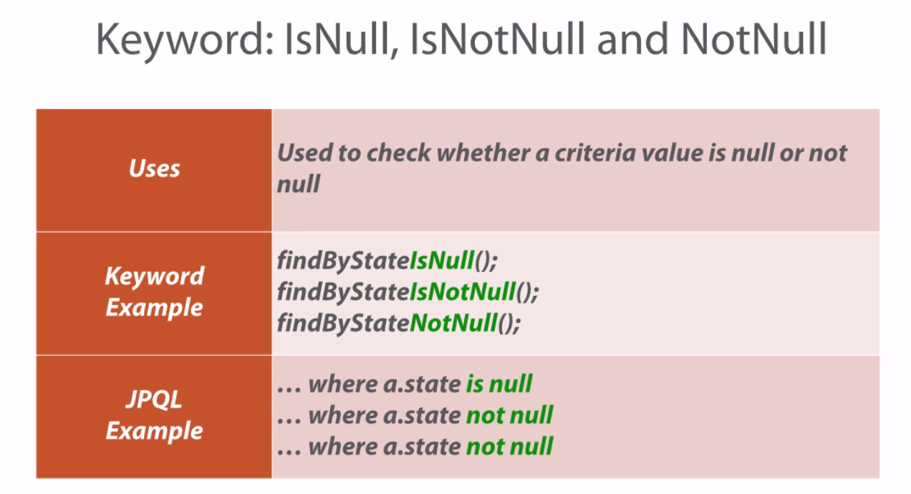

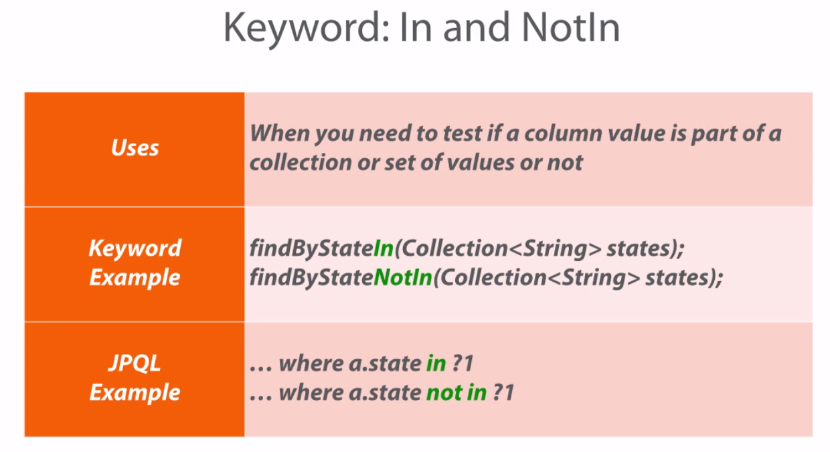

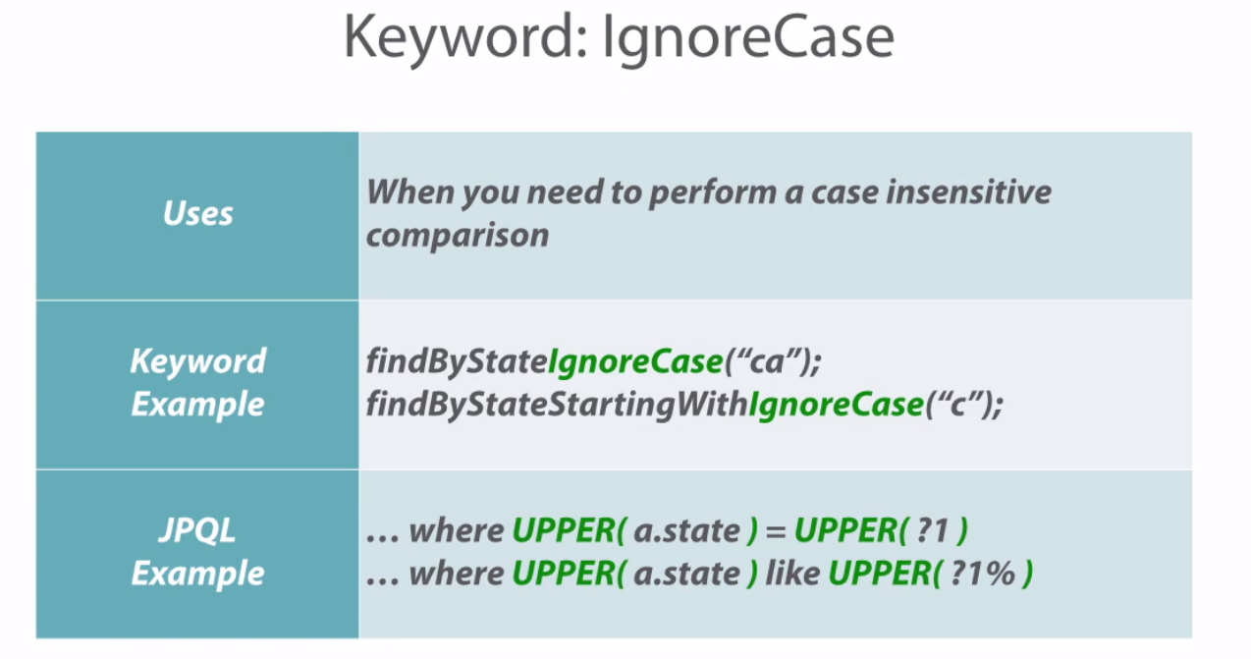

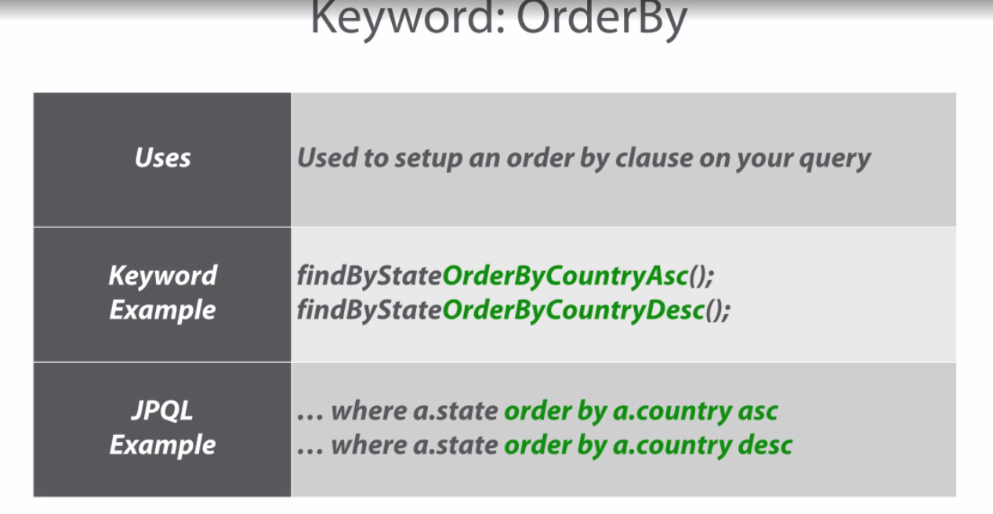

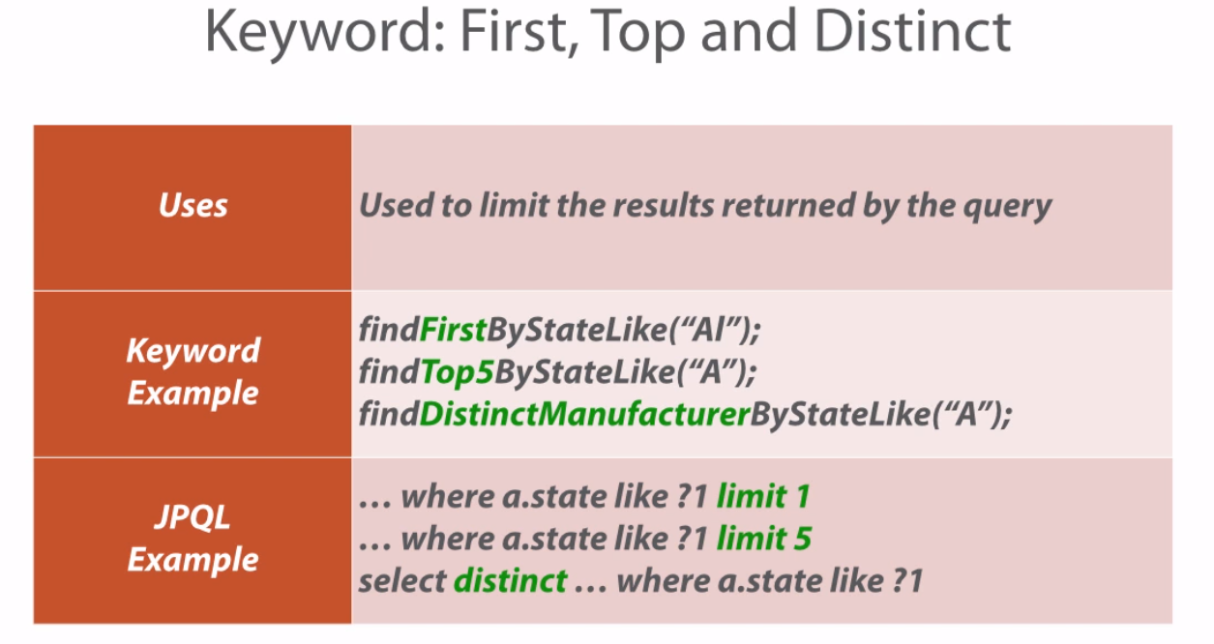

@Query Annotation

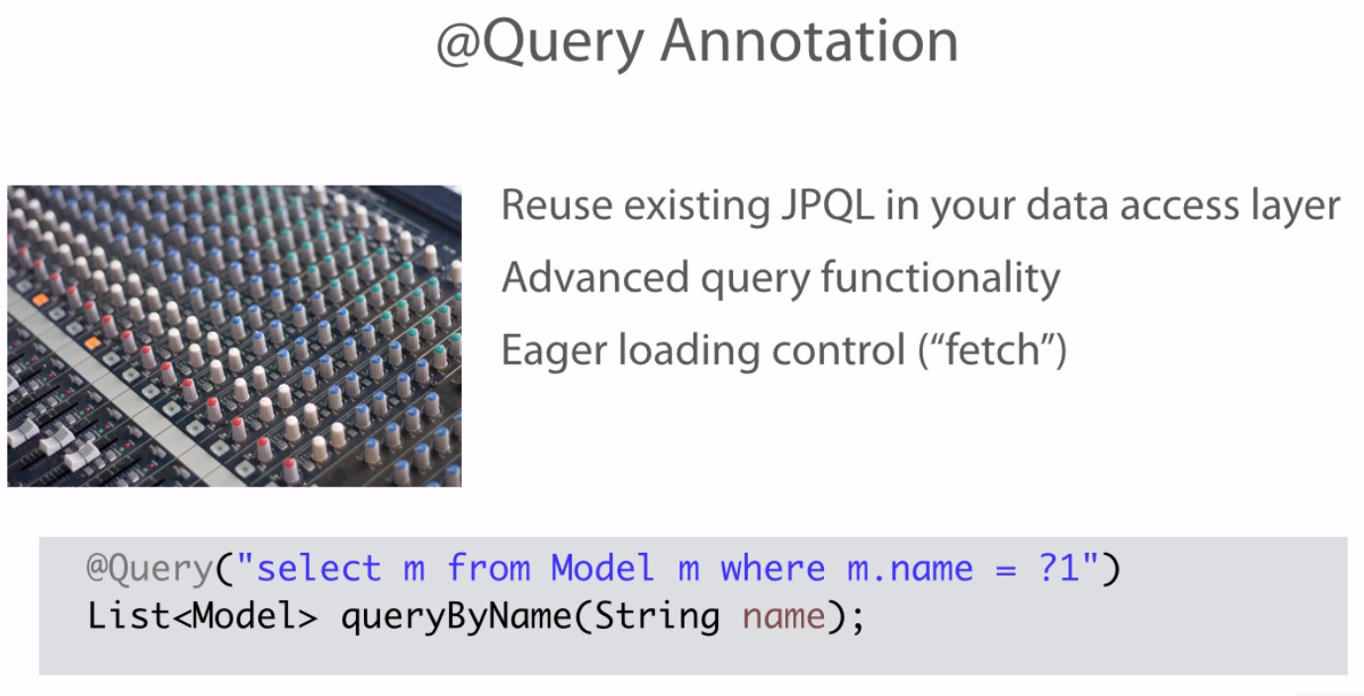

**Various Query Options using @QueryAnnotation:**

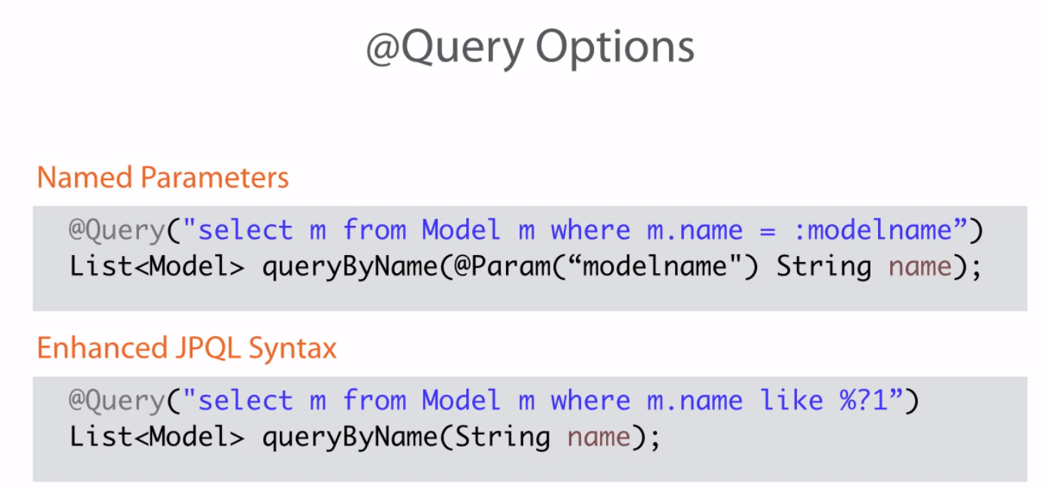

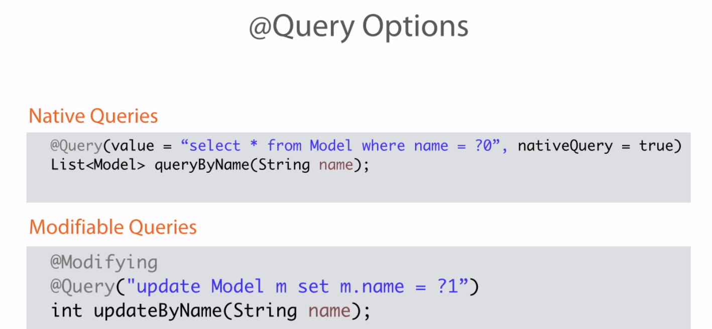

**Two ways of using JPA Named Queries**

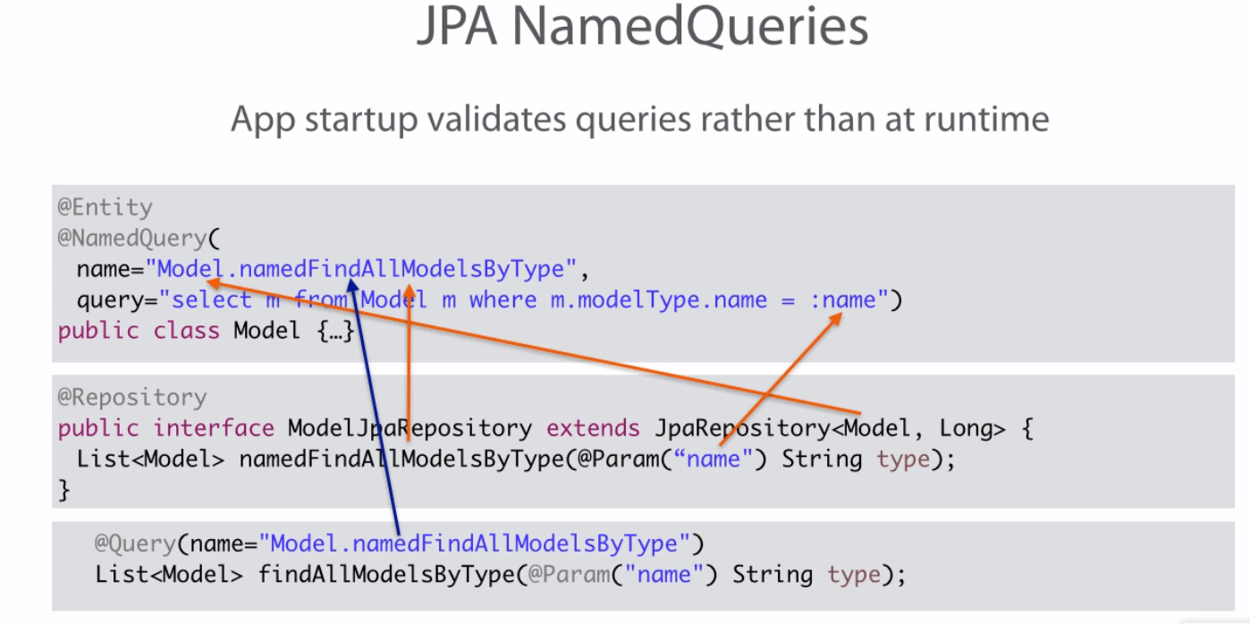

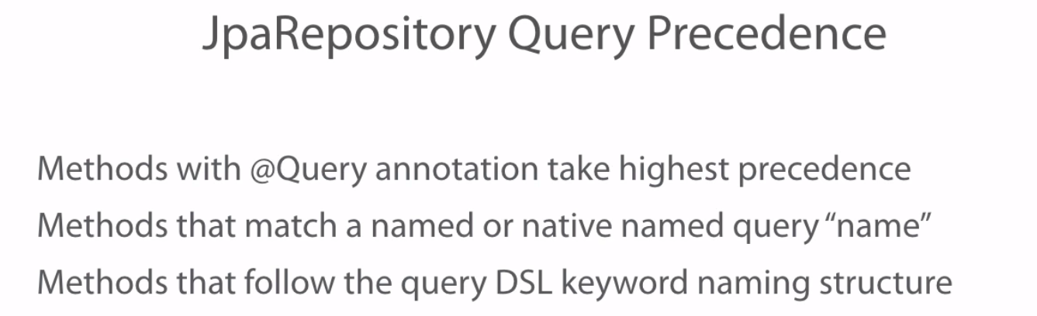

Example :

Methods that match a named query name,

List<Model> findAllModelsByType(@Param("name") String name);

Methods that match a named native query name,

List<Manufacturer> getAllThatSellAcoustics(String modelType);

Paging and Sorting

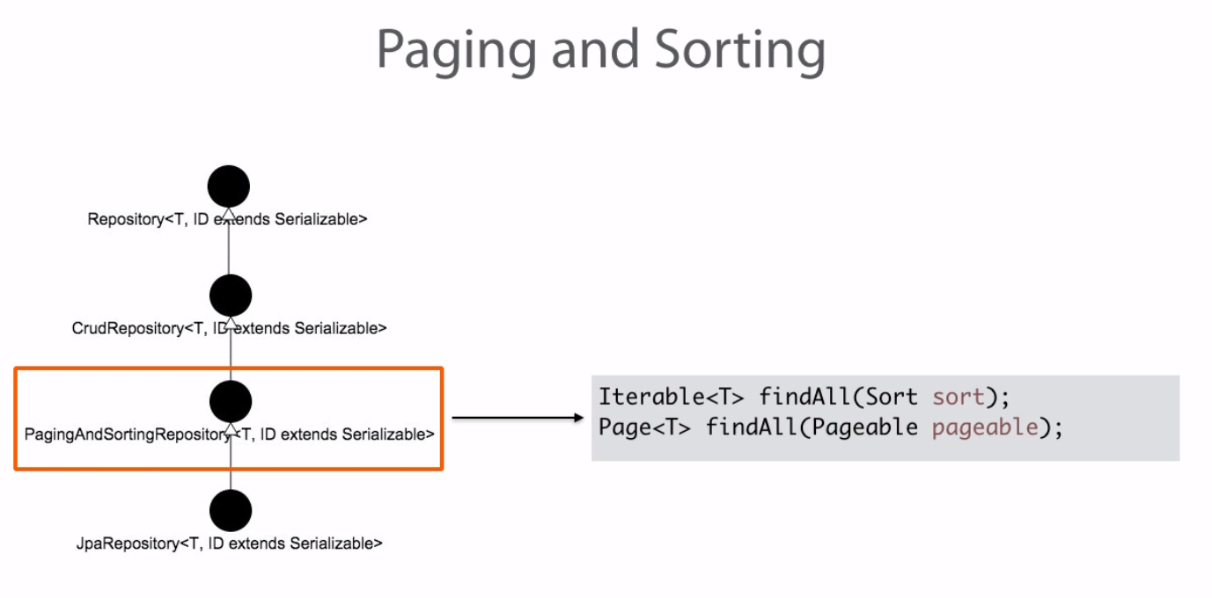

Custom Repositories

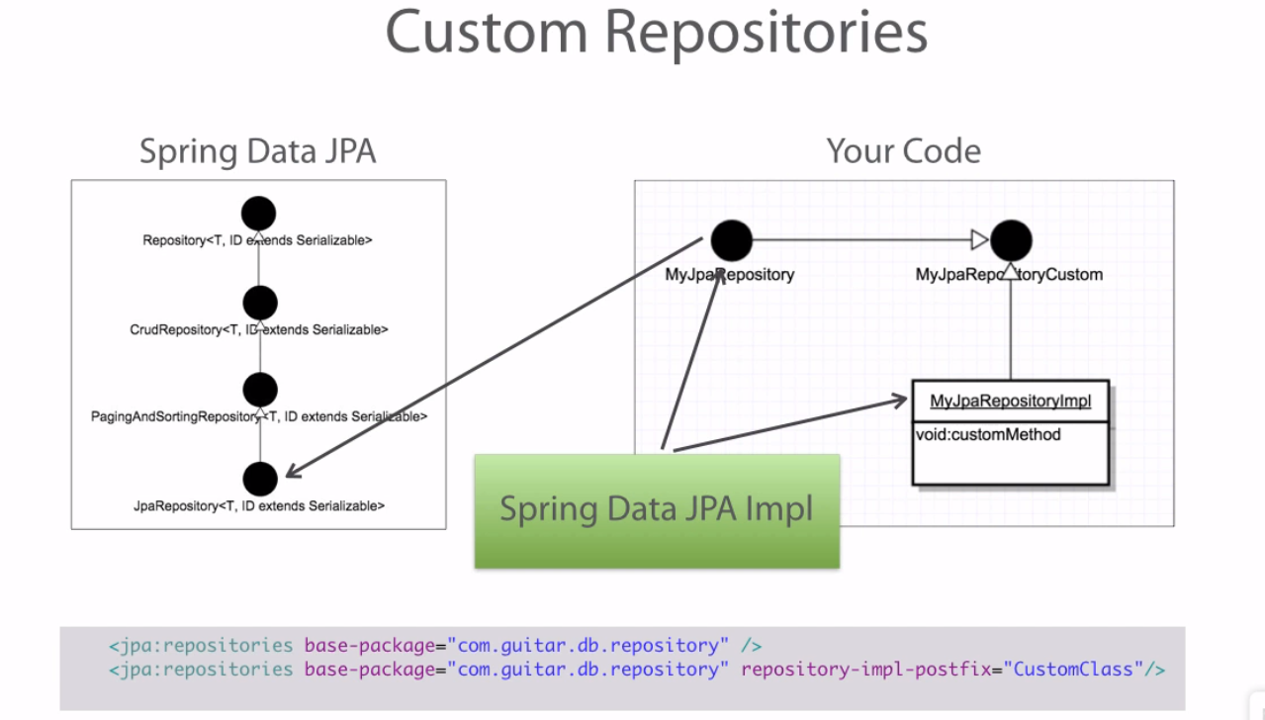

Workspace Reference: C:\Users\stkra\Documents\Spring\spring_dataJPA_workspace

Execution: Validate by running the unit tests available.

**Course Name : Getting started with Spring Data REST by Dan Bunker in pluralsight**

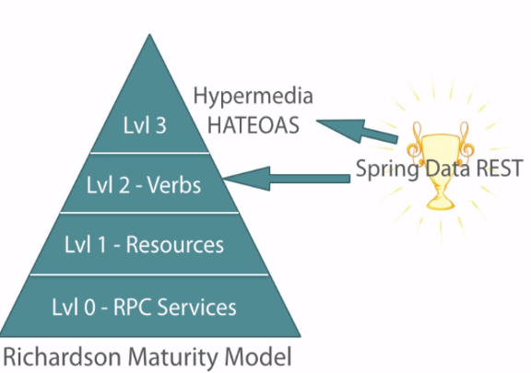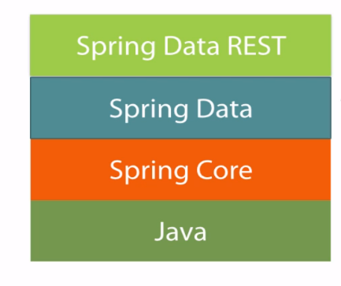

Integrating Spring data rest

For a Spring Boot project,

<dependency>

<groupId>org.springframework.boot</groupId>

<artifactId>spring-boot-starter-data-rest</artifactId>

</dependency>

For a Non-Spring Boot project,

<dependency>

<groupId>org.springframework.data</groupId>

<artifactId>spring-data-rest-webmvc</artifactId>

<version>2.3.0.RELEASE</version>

</dependency>

Along with the above entry in pom.xml, you have to install the Spring Data REST in a non spring boot application by importing or extending the RepositoryRestMvcConfiguration & overriding any of the configuration methods,

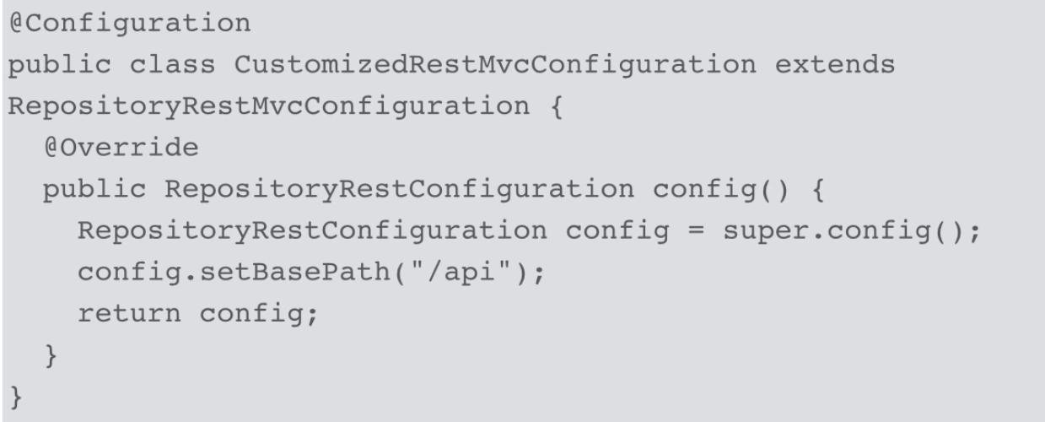

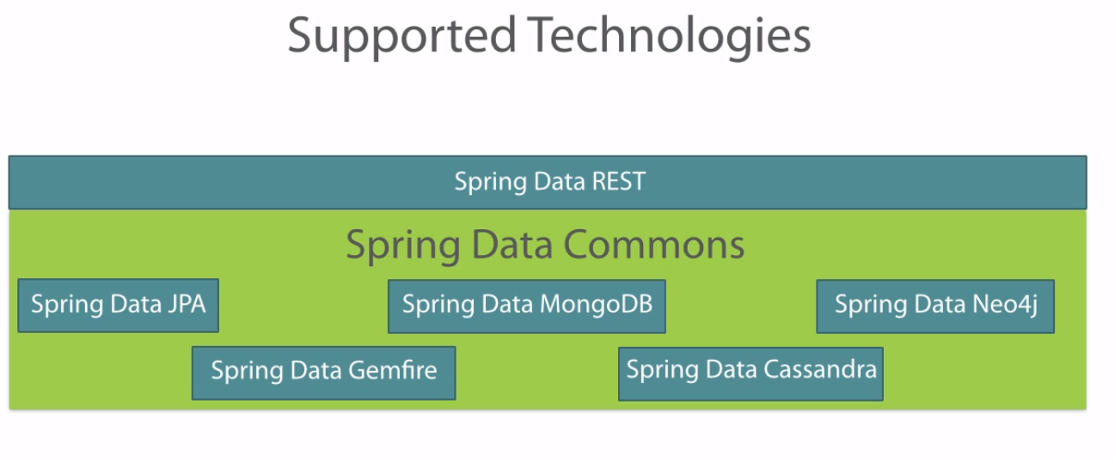

Figure 1 Spring Data REST supports the data access layer technologies that relies on Spring Data Commons repository interface hierarchy

Spring Data REST Architecture

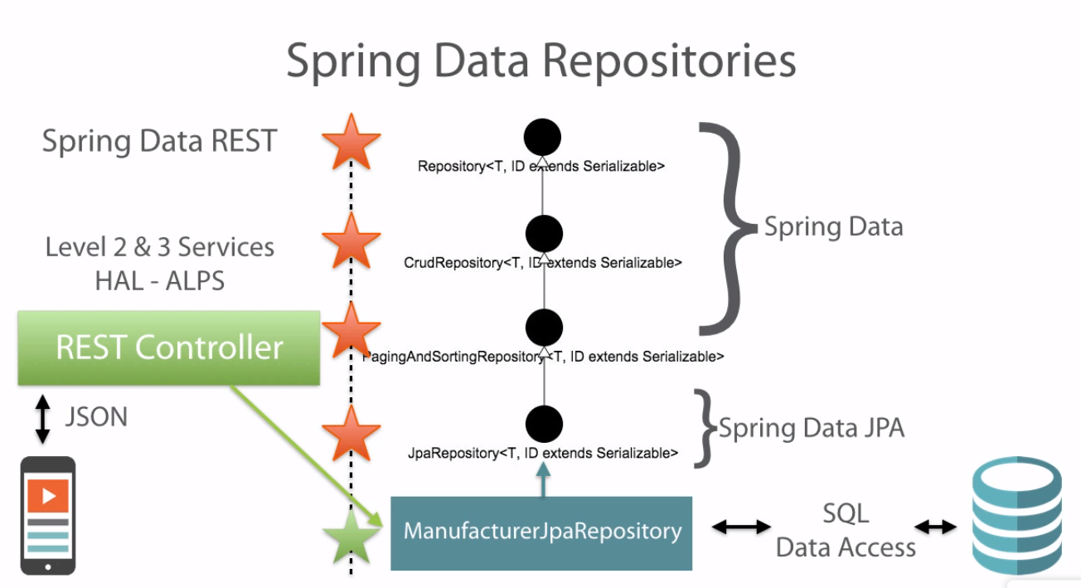

Spring Data/Spring Data JPA : On Data access side, Spring Data or Spring Data JPA repositories are going to access the data for you without you implementing code to access them.

Spring Data REST: It works its magic at application start up just like Spring Data does. As soon as it finds an Spring Data Repository, it creates hidden Spring MVC REST Controller for that repository. This generated REST controller is responsible for exposing all of the REST endpoints that the clients can call and interact with. Spring Data REST will implement all repository methods from your custom repository and the parent repositories will be mapped to the resource URL and set up to use the HTTP verbs for the basic resource pattern.

In short, You don’t need to do any implementation on the data as well as on the controller. All you have to do is to set up the repository. Spring Data REST is going to do the remaining for you.

Client 🡪 Spring Data REST controller 🡪 Spring Data 🡪 Data

*Example* : Refer ManufacturerJPARepository in the workspace.

@Repository

**public** **interface** ManufacturerJpaRepository **extends** JpaRepository<Manufacturer, Long> {

List<Manufacturer> findByFoundedDateBefore(Date date);

List<Manufacturer> findByActiveTrue();

List<Manufacturer> findByActiveFalse();

List<Manufacturer> getAllThatSellAcoustics(String name);

}

Once the app is started, you have to frame the endpoint like this,

http://localhost:8080/api/manufacturers

*Result –* It will have 3 sections links, embedded, page

{

"_links" : {

"self" : {

"href" : "http://localhost:8080/api/manufacturers{?page,size,sort}",

"templated" : true

},

"search" : {

"href" : "http://localhost:8080/api/manufacturers/search"

}

},

"_embedded" : {

"manufacturers" : [ {

"name" : "Fender Musical Instruments Corporation",

"foundedDate" : "1946-01-01T06:00:00.000+0000",

"averageYearlySales" : 25000000.00,

"active" : true,

"_links" : {

"self" : {

"href" : "http://localhost:8080/api/manufacturers/1"

},

"models" : {

"href" : "http://localhost:8080/api/manufacturers/1/models"

},

"headquarters" : {

"href" : "http://localhost:8080/api/manufacturers/1/headquarters"

}

}

}, {

"name" : "Gibson Guitar Corporation",

"foundedDate" : "1902-01-01T06:00:00.000+0000",

"averageYearlySales" : 32000000.00,

"active" : false,

"_links" : {

"self" : {

"href" : "http://localhost:8080/api/manufacturers/2"

},

"models" : {

"href" : "http://localhost:8080/api/manufacturers/2/models"

},

"headquarters" : {

"href" : "http://localhost:8080/api/manufacturers/2/headquarters"

}

}

} ]

},

"page" : {

"size" : 20,

"totalElements" : 2,

"totalPages" : 1,

"number" : 0

}

}

Now where are those 4 methods declared in the actual interface? Spring Data REST will take any query DSL methods that it finds in your custom repository and lump them underneath searchable endpoints, so if you look in the _links area you will see the search section with the url. Issuing a get request on this url will get me all the 4 methods declared in this interface.

<http://localhost:8080/api/manufacturers/search>

{

"_links" : {

"findByActiveTrue" : {

"href" : "http://localhost:8080/api/manufacturers/search/findByActiveTrue"

},

"findByFoundedDateBefore" : {

"href" : "http://localhost:8080/api/manufacturers/search/findByFoundedDateBefore"

},

"findByActiveFalse" : {

"href" : "http://localhost:8080/api/manufacturers/search/findByActiveFalse"

},

"getAllThatSellAcoustics" : {

"href" : "http://localhost:8080/api/manufacturers/search/getAllThatSellAcoustics"

}

}

}

Spring Data REST Resource Pattern

1. Spring Data REST builds a standard resource template pattern around your Spring Data Repository. Each Spring Data Repository is considered as a single REST resource.

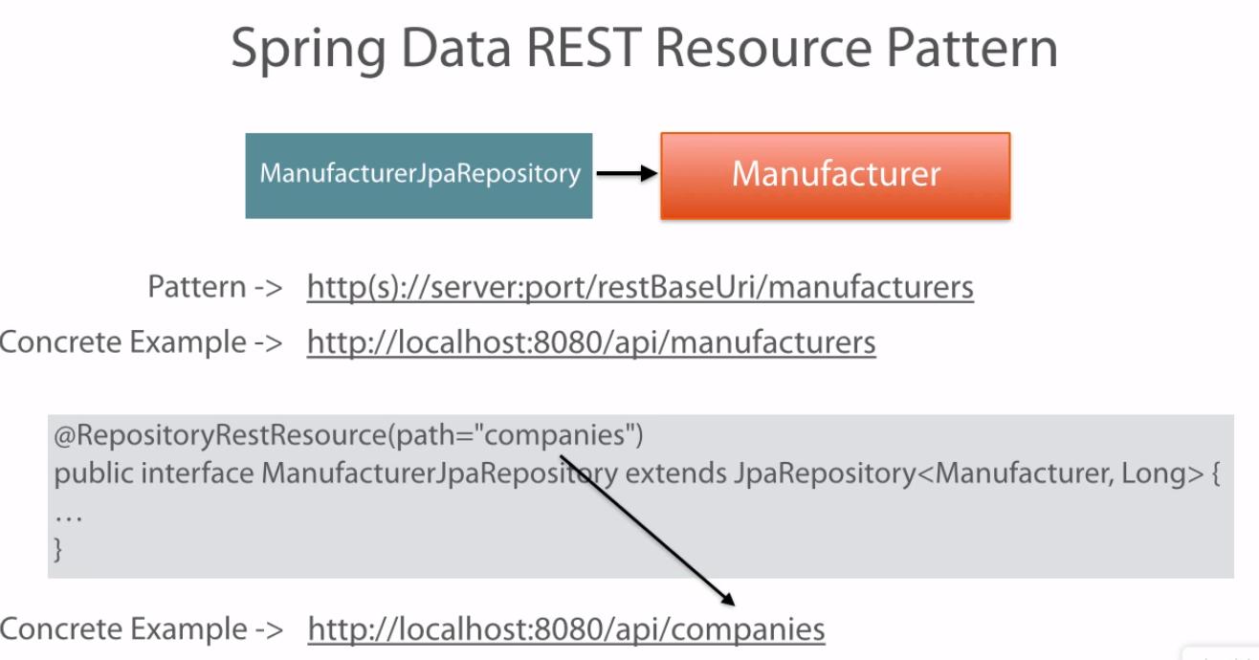

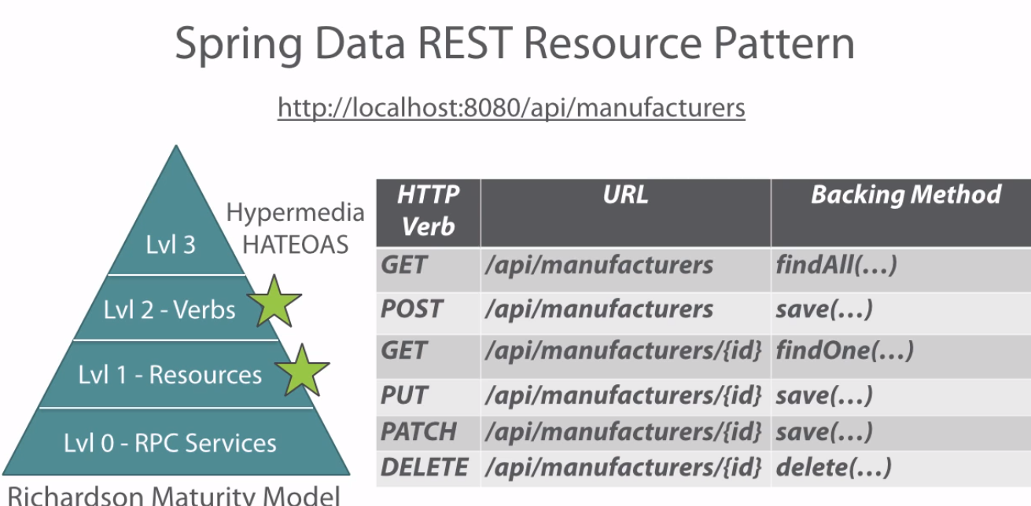

|  |  |
| --- | --- |
| HTTP Verb | Success Code |
| GET | 200 ok |
| POST | 201 created |
| PATCH/PUT | 204 No content |
| DELETE | 204 No Content |

Customizing Services:

1. If we don’t have the repository to be exposed as a REST service, use the following annotation at the JPA repository, @RepositoryRestResource(exported=**false**)
2. If we want to change the url, that is the pluralized form of the entity that is tied to the repository, use the following annotation. @RepositoryRestResource(path="mfgs")
3. If we want to change the collection string name in the embedded section in the payload in addition to changing the url, @RepositoryRestResource(path="mfgs", collectionResourceRel="mfgs")

Association Resources: To update or delete any parent data or child data, you will have to link or unlink the data, rather than doing the actual update.

Spring Data REST projection:

Spring Data REST presents a default view of the domain model you are exporting. But sometimes, you may need to alter the view of that model for various reasons. Projections serve up simplified and reduced views of resources.

**A projection is a special type of contract that you declare to describe what fields you want to include in a response object. In terms of Java, a projection is simply an interface that declares what fields should be sent to the client.**

Projection interface should be in the same package of the entity or in entity’s sub package. If its some other package, Framework will not identify.

Sample Projection Interface:

@Projection(name="modelDetail", types=Model.**class**)

**public** **interface** ModelDetail {

String getName();

BigDecimal getPrice();

**int** getFrets();

String getWoodType();

Date getYearFirstMade();

Manufacturer getManufacturer();

ModelType getModelType();

}

URL: <http://localhost:8080/api/models?projection=modelDetail>

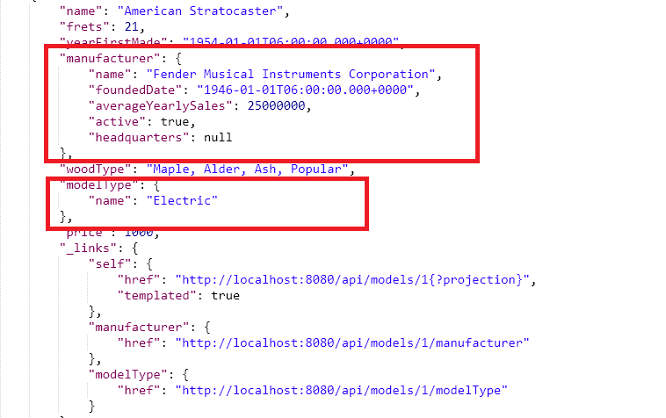

Virtual Projection

Projection can also generate virtual data using @value annotation. @value annotation uses Spring expression language to get the virtual data.

@Projection(name="modelDetailView", types=Model.**class**)

**public** **interface** ModelDetailView {

@Value("#{target.name}")

String getModelName();

BigDecimal getPrice();

**int** getFrets();

String getWoodType();

Date getYearFirstMade();

@Value("#{target.manufacturer.name}")

String getManufacturerName();

ModelType getModelType();

@Value("#{target.manufacturer.name.split(' ')[0]} #{target.name}")

String getFullName();

}

<http://localhost:8080/api/models?projection=modelDetailView>

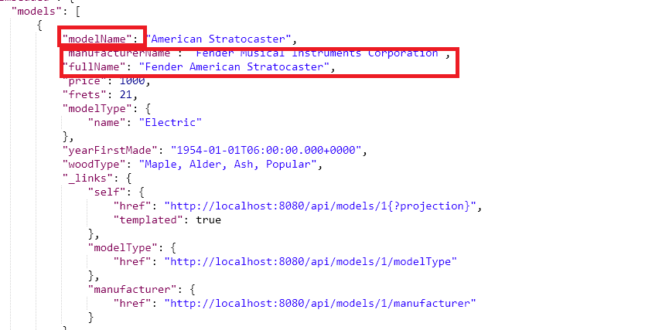

Projection Excerpts:

An excerpt is a projection that is applied to a resource collection automatically. It does not apply to individual item resource

@RepositoryRestResource(excerptProjection=ModelDetailView.**class**)

**public** **interface** ModelJpaRepository **extends** JpaRepository<Model, Long>, ModelJpaRepositoryCustom {

List<Model> findByPriceGreaterThanEqualAndPriceLessThanEqual(BigDecimal low, BigDecimal high);

List<Model> findByModelTypeNameIn(List<String> types);

@Query("select m from Model m where m.price >= :lowest and m.price <= :highest and m.woodType like :wood")

Page<Model> queryByPriceRangeAndWoodType(@Param("lowest") BigDecimal lowest,

@Param("highest") BigDecimal high,

@Param("wood") String wood,

Pageable page);

List<Model> findAllModelsByType(@Param("name") String name);

}

<http://localhost:8080/api/models>

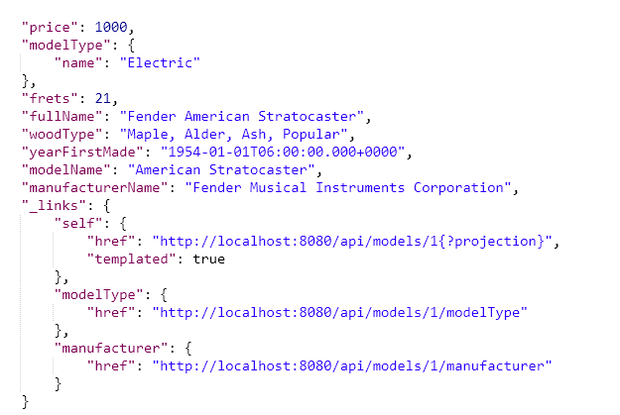

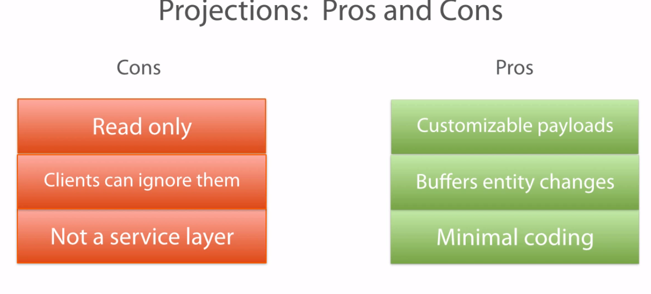

Figure 2 **Read Only** means it can be applied to get request not update or create request. Clients can ignore to use the projection and go with the actual url. **Not a service laye**r to include all business logic

Jackson Payload options

Jackson Json Parser : Spring Data REST uses Jackson JSON Parser to automatically convert the java entity to JSON and vice-versa. Payload can be customized as well.

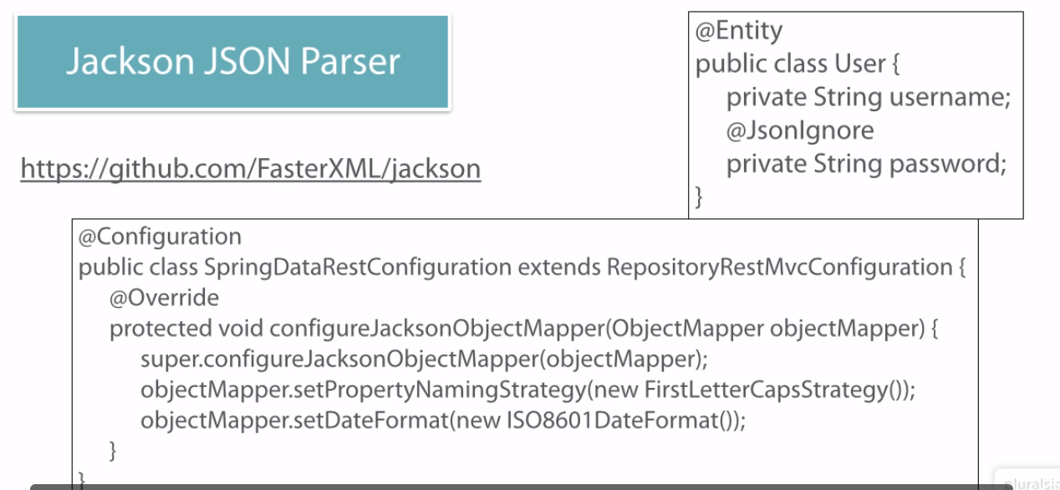

Securing a REST API:

Authentication:

1. Adding a dependency to access the security in pom.xml

<dependency>

<groupId>org.springframework.boot</groupId>

<artifactId>spring-boot-starter-security</artifactId>

</dependency>

1. Setting up the in memory or Oauth based configuration using Java

@Configuration

@EnableWebSecurity

@EnableGlobalMethodSecurity(prePostEnabled=**true**)

**public** **class** SecurityConfiguration **extends** WebSecurityConfigurerAdapter{

@Autowired

**public** **void** configureGlobal(AuthenticationManagerBuilder auth)**throws** Exception{

auth.inMemoryAuthentication().withUser("raajee").password("raajee").roles("USER").

and().

withUser("admin").password("admin").roles("USER","ADMIN");

}

@Override

**protected** **void** configure(HttpSecurity http)**throws** Exception{

**super**.configure(http);

http.csrf().disable();

}

}

1. Sending the Authorization header in the REST api call

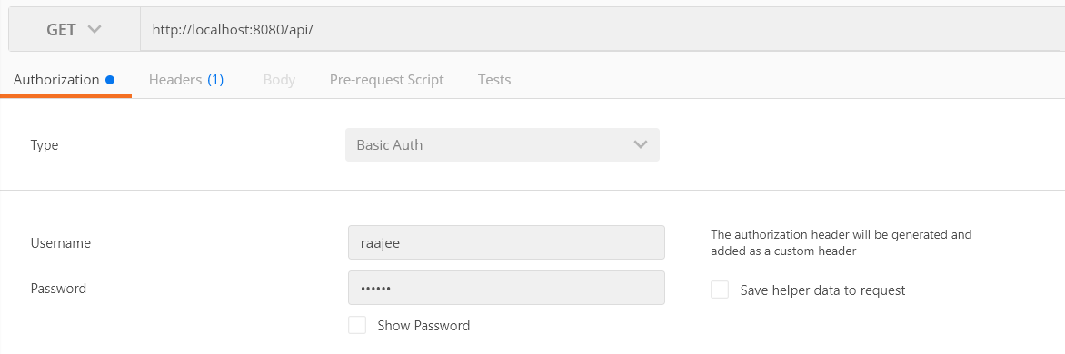

Once you provide the credentials, Postman automatically creates the authorization header for us,

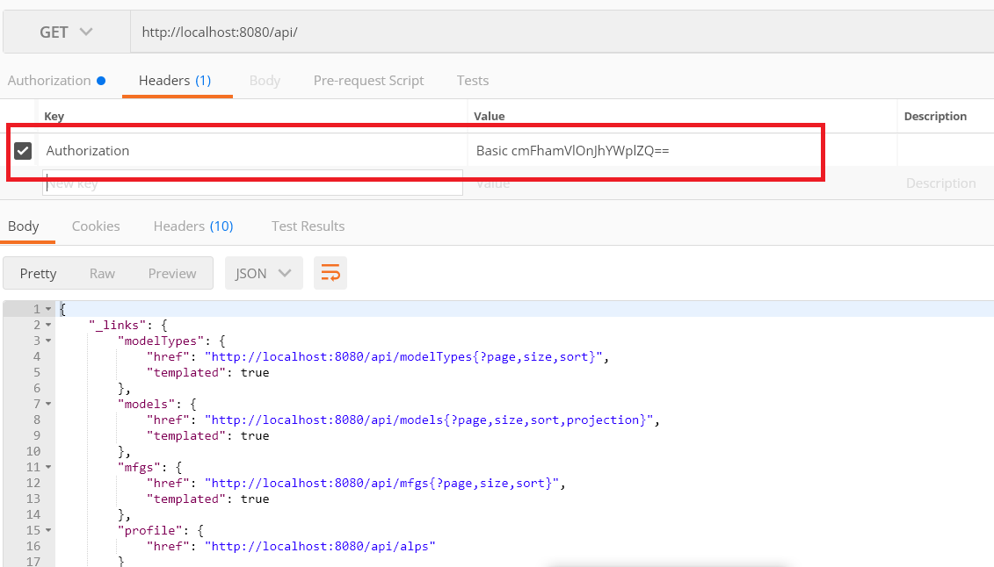

Authorization:

@EnableGlobalMethodSecurity(prePostEnabled=**true**)

@PreAuthorize("hasRole('ROLE_ADMIN')") – Putting this at the class level will limit admin access to all the methods present in this class. But not for the whole interface. To protect the whole thing, you have to identify the parent class methods and put it like follows,

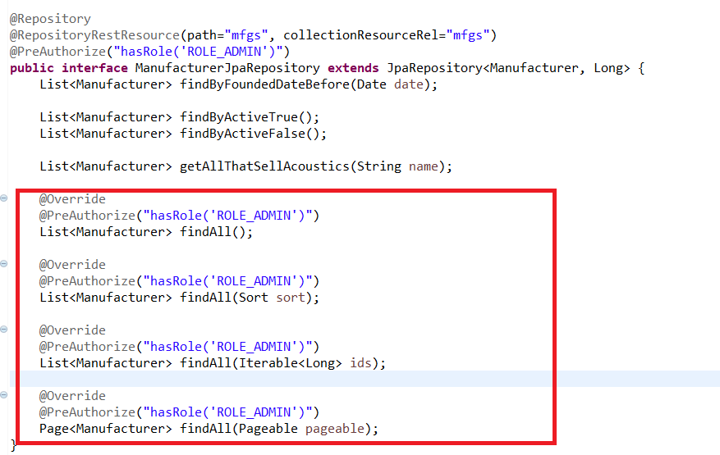

The reason why individual parent methods has to be secured is, if we don’t provide that only the methods present in the custom repository will be authorized.

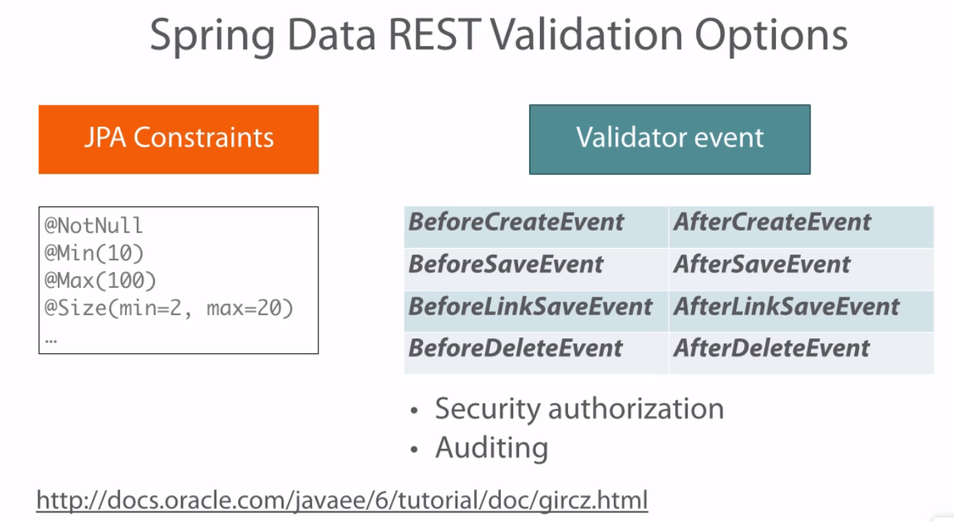

Sample Validator class:

@Component

@RepositoryEventHandler(Manufacturer.**class**)

**public** **class** ManufacturerEventHandler {

@HandleBeforeCreate

**public** **void** handleBeforeCreate(Manufacturer m) {

**if**(!m.getActive()) {

**throw** **new** IllegalStateException("New manufacturer must be active");

}

}

}

REST Hypermedia

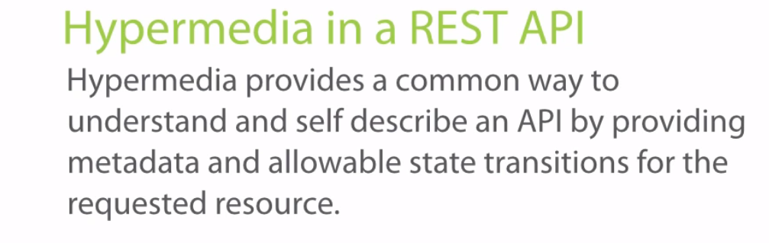

HypeMedia Formats Spring DATA REST uses:

*HAL :* Hypertext Application Language. It can be used to wrap a resource with the link metadata of all possible resource paths you can transition to from current resource. This is the default media type Spring Data REST uses.

Default Content Type Spring Data REST uses is application/HAL+JSON

*ALPS*: Application Level Profile Semantics. It is used to tell about the resource attributes, all of its related operations and their particular semantics. It differs from HAL links telling how safe or risky calling one of the API endpoints are.

*JSON Schema:* This is similar to HAL and ALPs but one area stands out with JSON schema over other formats. It tells what datatypes each of the attributes are.

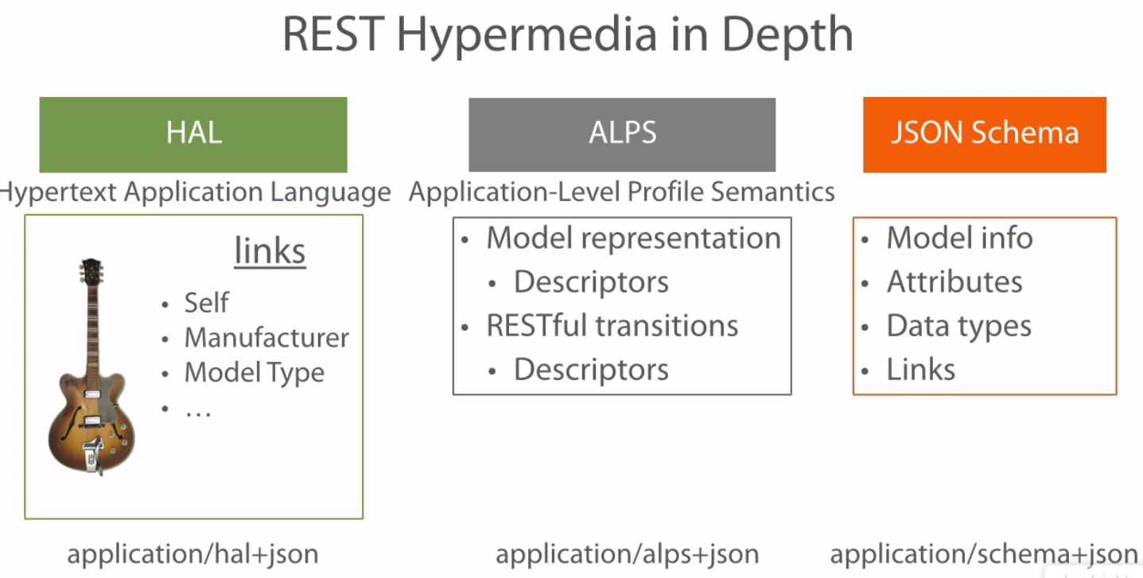

Workspace Reference: C:\Users\stkra\Documents\Spring\ spring_data_REST_workspace

Execution: Use Postman to access the APIs

Difference between @Controller, @RestController, @RepositoryRestResource

In many scenarios as a part of API we need to provide endpoints for searching an entity based on certain criteria. Now using JPA you don't have to even write queries, just make an interface and methods with specific nomenclature of Spring-JPA. To expose such APIs you will make Service layer which would simply call these repository methods and finally Controllers which will expose endpoints by calling Service layer.

What Spring did here, allow you to expose these endpoints from such interfaces (repositories) which are generally GET calls to search entity and in background generates necessary files to create final endpoints. So if you are using @RepositoryRestResource then there is no need to make Service/Controller layer. This creates a HATEOS service as well by default

On the other hand @RestController is a controller that specifically deals with json data and rest work as a controller.This doesn’t support HATEOS fo In short @Controller + @ResponseBody = @RestController.

**Spring BOOT**

**Course Name : Creating your first spring boot application by Dan Bunker in pluralsight**

Java 1.8+ is required for spring boot

**Creating your first App**

Maven Dependencies:

<parent>

<groupId>org.springframework.boot</groupId>

<artifactId>spring-boot-starter-parent</artifactId>

<version>1.5.8.RELEASE</version>

</parent>

<dependency>

<groupId>org.springframework.boot</groupId>

<artifactId>spring-boot-starter-web</artifactId>

</dependency>

Spring Boot Dependency Management:

*BOM – Bill of Materials* : Spring Boot calls its intelligent collection of dependencies as BOM. When the spring boot starter parent is included, that parent brought in all of the dependency management The starter parent also sets up other defaults that are useful to the project like plugins, Java Minimum version and so on.

Other Spring Boot Initializer: Spring Boot Initializr is a boot strap or an archetype, or skeleton or shell creator for our project. It takes care of lot of boilerplate that is necessary to get a project going and it allows you to just get started coding.

1. Web Initializer([http://start.spring.io):](http://start.spring.io):%20)  You give all the details in the web site and the project will be generated and available as zip file
2. Command Line(Spring Boot CLI)
3. Git Hub url(<https://github.com/spring-projects/spring-boot/tree/master/spring-boot-samples>) – Download the project and make changes to the Business rules appropriately

How does Spring Boot work?

1. Java – Main method entry point
2. Spring Application – Spring Boot initializes the Spring Context that comprises your Spring app and then honours any auto-config initializers, configuration and annotations that direct how to initialize and start up the Spring Context.
3. Last, an embedded servlet container(Default server is Tomcat, but there are options to swap with Jetty) is started and auto configured. This has removed the need for web.xml

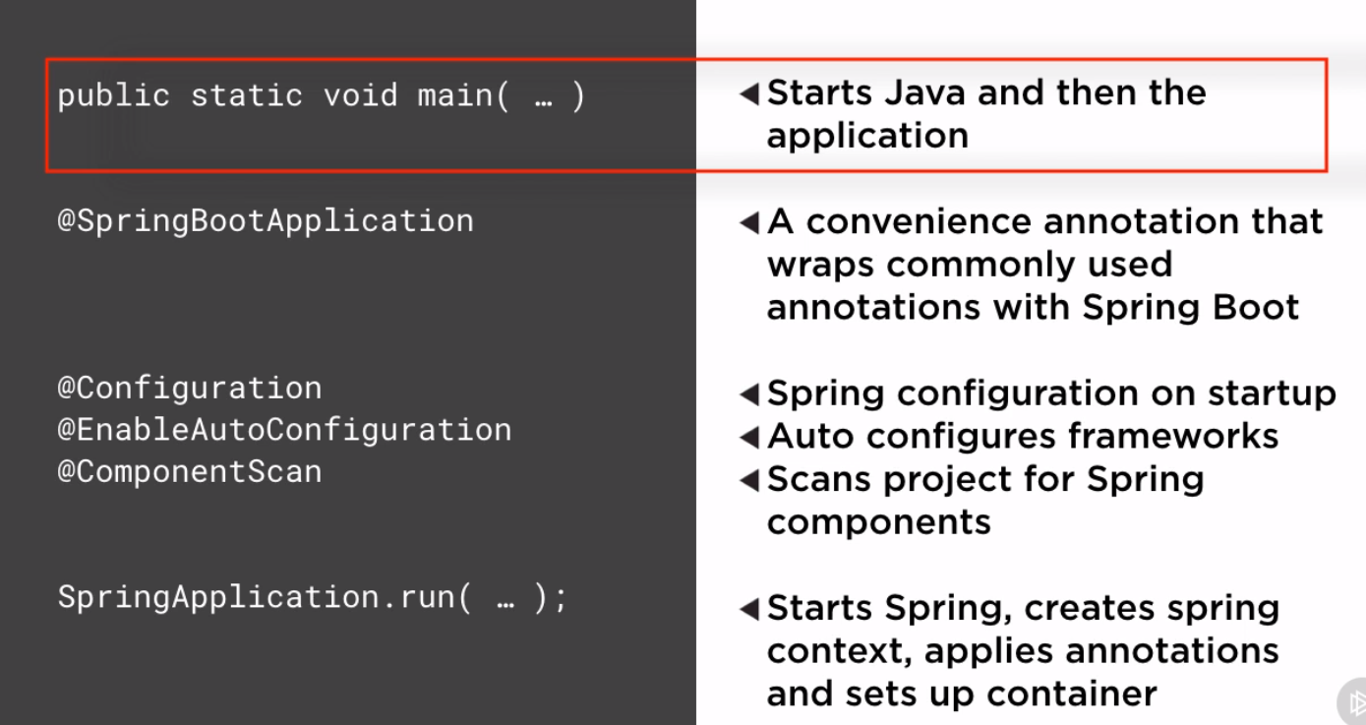

*@SpringBootApplication :* This directs how to initialize and start up Spring. This sets up the following annotations @Configuration, @EnableAutoConfiguration, @ComponentScan under the cover.

@Configuration : classifies the java class as a configuration for the Spring context the Spring Boot and Spring will use to initialize and configure various components in environment settings used by Spring. This is equivalent to older spring xml based configuration

@ EnableAutoConfiguration : Spring Boot specific annotation.This tells spring boot if it finds any Spring subprojects or other spring compatible frameworks on the classpath that it should attempt to auto configure them and get them wired up and integrate automatically with Spring. When combined with maven bill of materials, this brings all the sub framework. For eg, when starter web dependency is added, this annotation brought in Spring MVC Framework.

@ComponentScan: This annotation tells to look for services, repositories, controllers or any other spring components starting in the package of App.java. Therefore App.java should always be kept at the top level of your main package structure. Else, all components will not be identified.

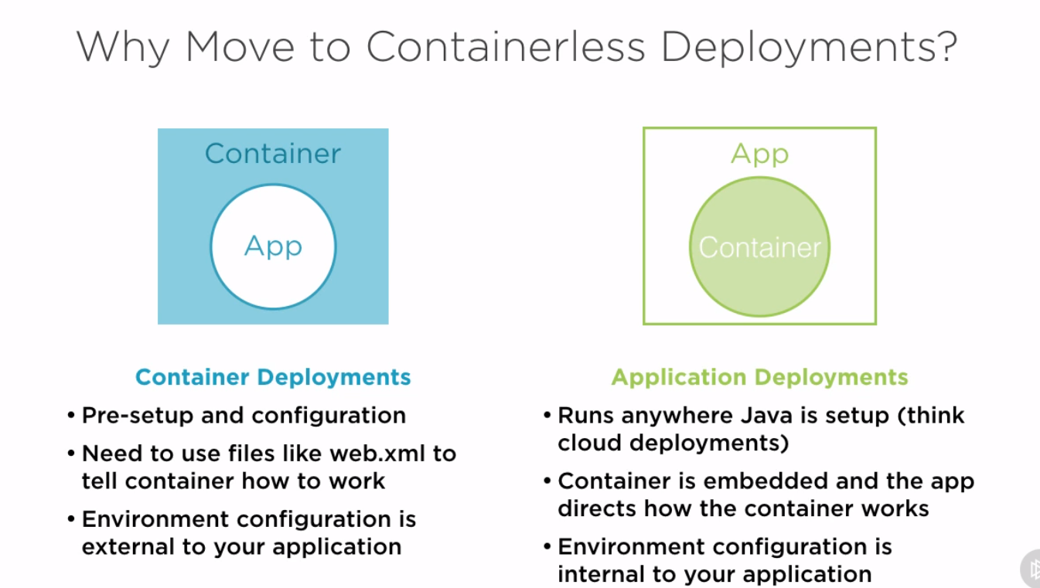

Container will be available in the JAR file you create, so there is no need for any web server/app server

URL: <http://localhost:8080/>

Workspace Reference: C:\Users\stkra\Documents\Spring\springboot_workspace

Project:das-boot

How to run the app.? Run the App.java as Java Application. Then hit the url,http://localhost:8080/

**Creating Web Apps –** Normally all web pages should be under src/main/webapp. But this folder can be overridden using application.properties by using the configuration spring….prefix.

1. Integrating java based UI: Clone the Angular UI code from git hub url and paste them in src/main/resources/public folder. Spring boot has several areas that will by default serve static content from. Default static content locations are – classpath/static, classpath/public, classpath/resources. These areas can be overridden.
2. Creating REST endpoints: Created a controller with all 5 CRUD url methods.
3. Spring MVC Integration Overview:

* When we added thespring-boot-starter-web in pom.xml, Spring boot simply included the Spring MVC in the class path. We also have the auto configuration enabled with our spring boot application. So Spring boot goes one step forward and sets up some Spring MVC features for us.
* Then it sets up the view resolvers automatically
* Then Spring boot told spring MVC to serve static resources located at the root of classpath in the static, public or resources path
* Spring boot then sets up some standard Spring MVC HTTPMessageConverters so that it can use sensible defaults to convert JSON object to Java object and vice versa.
* Then Spring boots sets up some customizable hooks to allow the user to override the default behavior

1. Overriding the default properties : Place the application.properties in the classpath.Application properties can be yaml files or standard properties. You can also add profiles for each environment. Application-{profile}.properties. These profile properties file will be loaded over the main application.properties file and any environment specific properties will be overriden and set for that environment.

-Dspring.profiles.active=test

URL: <http://localhost:8080/index.html>

Workspace Reference: C:\Users\stkra\Documents\Spring\springboot_workspace

Project:das-boot

**Configuring and accessing a datasource**

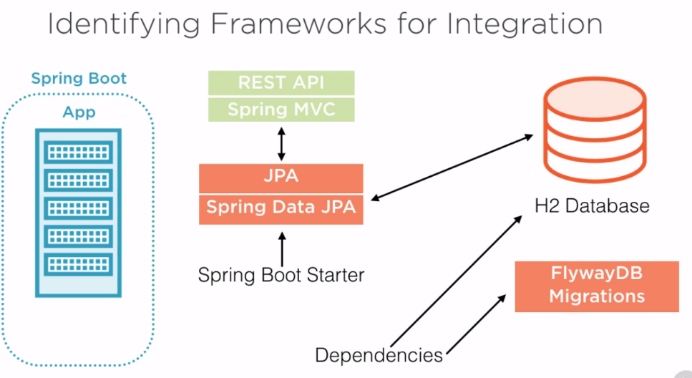

1. *Provisioning and integrating a database:*

Adding the following dependencies will provision and integrate h2 db,

<dependency>

<groupId>org.springframework.boot</groupId>

<artifactId>spring-boot-starter-data-jpa</artifactId>

</dependency>

<dependency>

<groupId>com.h2database</groupId>

<artifactId>h2</artifactId>

</dependency>

1. *Configuring a datasource:*

In real world scenario, we wont be using h2 db. We will be using mysql, oracle etc, In that case, the database will reside on its own server, so we need to provide jdbc connection details for it. With Spring boot, we can configure our datasource with application.properties file.

Besides setting the datasource connection info, it also tries to automatically set up your datasource pooling for you. If Spring detects any of the common pooling libraries on your classpath, auto configuration will integrate that pool and tie it in your datasource. When the spring boot starter data jpa dependency was added, it pulled in tomcat-jdbc pooling library. Spring uses this pool as its default. Other pools Spring boot will integrate with are the HikariCP, Commons-DBCP, Commons-DBCP2

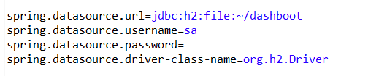

By storing database as a file, db will persist across server restarts. If we don’t store as a file, all changes done in a session will vanish when the server restarts.

URL to view the H2 console: <http://localhost:8080/h2>

1. *Integrating flywayDB:* Flyway is a database migration tool. It helps you to create the tables on the fly provided the flyway dependency in pom and db migratiom script.
2. Add the flyway dependency :

<dependency>

<groupId>org.flywaydb</groupId>

<artifactId>flyway-core</artifactId>

</dependency>

1. Configure flyway Datasource: Spring Boot will use the default datasource that is set up. But there are options to configure an alternative datasource for flyway.
2. Create migration scripts: The db migration script should be under the folder /db/migration in the classpath(src/main/resources). The name of the file should be something like this, V2__create_shipwreck.sql
3. Add the following properties in application.properties

flyway.baseline-on-migrate=true

spring.jpa.hibernate.ddl-auto=none

1. Migrate on app start up
2. *Defining multiple Datasources in PersistenceConfiguration class:*

@Bean – Annotation tells the return type datasource should be set up and stored as a spring bean in spring context.

@ConfigurationProperties – Annotation tells the datasource builder to use the connection and pulling properties located in the application.properties file where the properties begin with the prefix mentioned.

@Primary – Annotation that tells that this is the default datasource that should be used.

1. *Adding JPA and Spring Data JPA:*

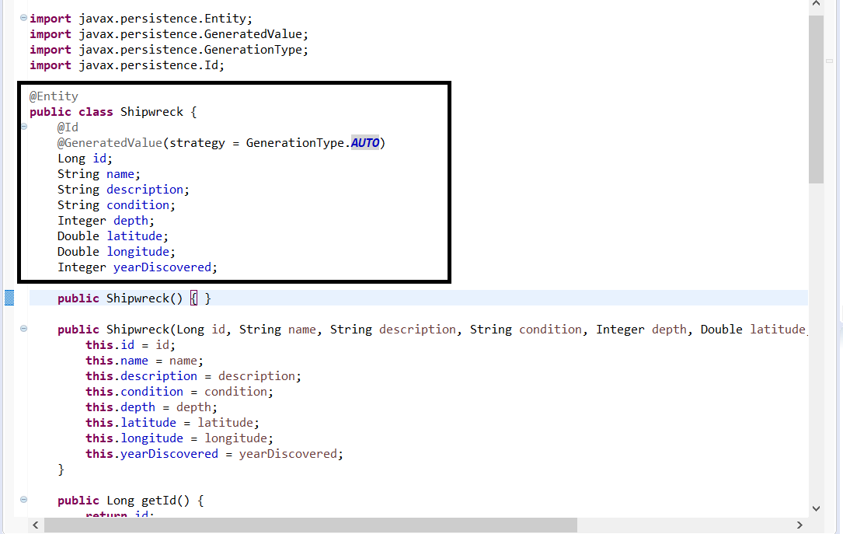

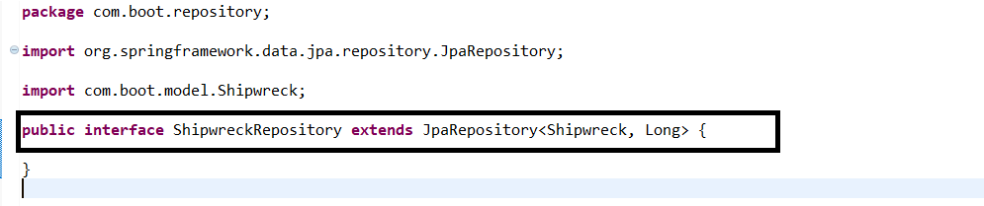

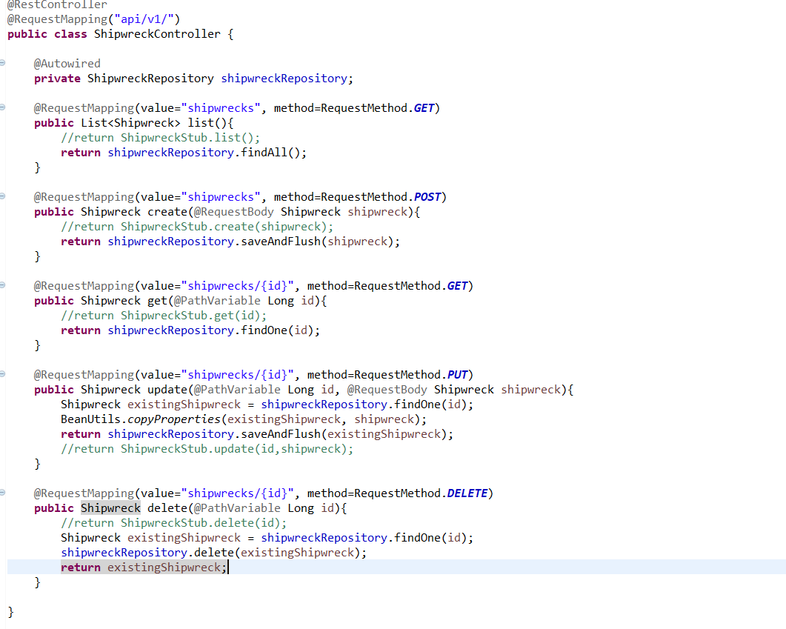

URL: <http://localhost:8080/index.html>

Workspace Reference: C:\Users\stkra\Documents\Spring\springboot_workspace

Project:das-boot

**Testing the Spring Boot Application**

*Writing up the starter and running the test:*

<dependency>

<groupId>org.springframework.boot</groupId>

<artifactId>spring-boot-starter-test</artifactId>

<scope>test</scope>

</dependency>

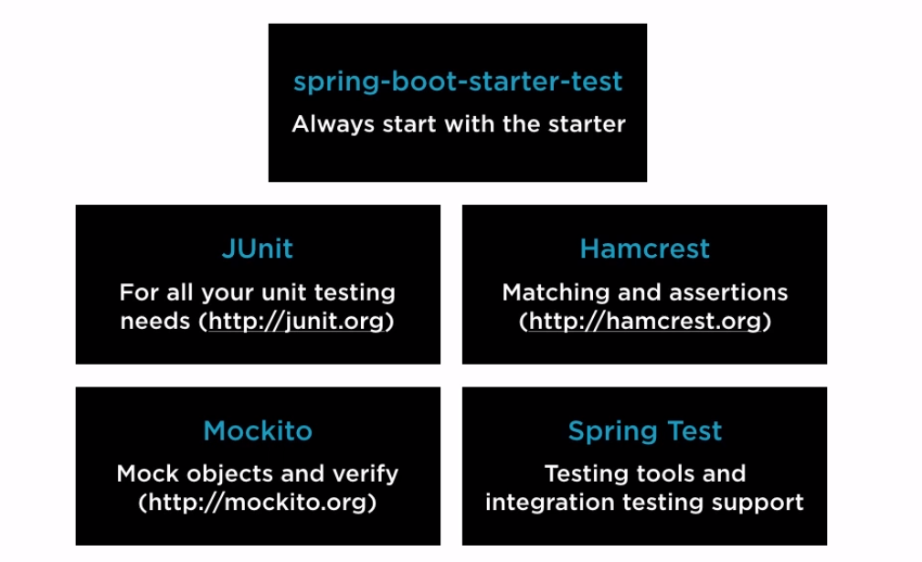

Notes:

* By default, Spring Boot doesn’t support jsp pages. You have to include tomcat-jasper dependency in pom.xml to support it
* Spring Boot supports auto configuration. You can change those auto configuration by using application.properties
* While integrating MVC with Spring Boot, we use ModelAndView class to set the data & view using setObject & setViewName methods. Request parameters can be got using @RequestParam annotation, @RequestParam(“name”) String name. If you want send multiple attributes of an POJO class, you can just refer it as “POJO class name, Object” and there is no need to use @RequestParam
* Instead of using flyway db to create table and load data, Spring Boot itself can handle table creation and data insertion. To do the table creation, just add @Entity in the model class. Then create a sql file under src/main/resources. Data will be loaded from sql file on start up.
* With @Controller annotation, you can make REST calls. Method should have @RequestMapping, @ResponseBody. Method Parameter should be @ParamVariable(“name”) String name
* To get the data in Json format, we already have Jackson jar by default which will convert Java object to json. Other changes to do, we have to change the return type of default methods like “findAll” from String to <Optional>Pojo Class. To do this, repository class should extend JPA repository not CRUD Repository.
* By default, Spring Boot provides Json format. To get xml format, you have to use the Jackson-dataformat-xml dependency in pom.xml
* To restrict only one format, you have to add an attribute (produces = “”) in @RequestMapping. Similarly

You have consumes attribute(used when we want to input data)

**Course Name : Spring Boot: Efficient Development, Configuration & Deployment by Dustin Schultz in pluralsight**

**Leveraging Initializr and Dev tools for efficient Development**

**Course Name : Spring Cloud Fundamentals by Dustin Schultz in pluralsight**

**1.Finding services using Service Discovery**

There will be service Discovery server. It will provide a way for a service to register itself, re-register itself, a way for a client to find other services, a way to check the health of the service and remove unhealthy services.

Services can be discovered by the following projects in Spring cloud:

* Spring Cloud Consul
* Spring Cloud Zookeeper
* Spring Cloud Netflix – Netflix Open source Project + Spring + Spring Boot

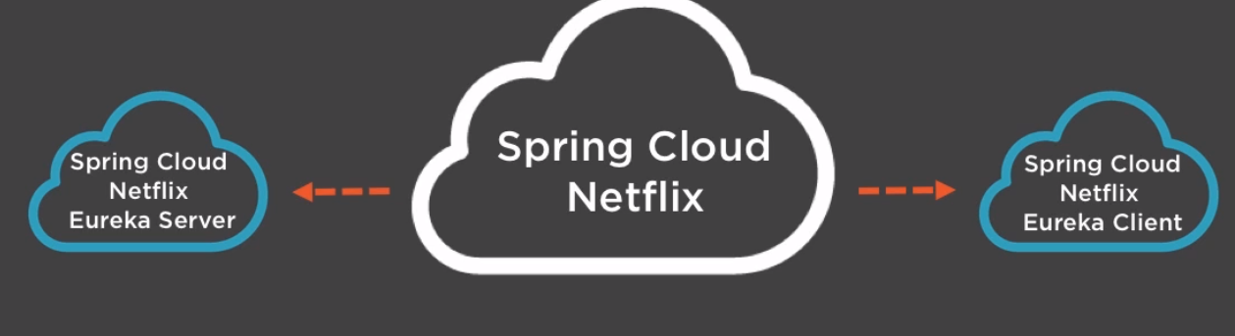

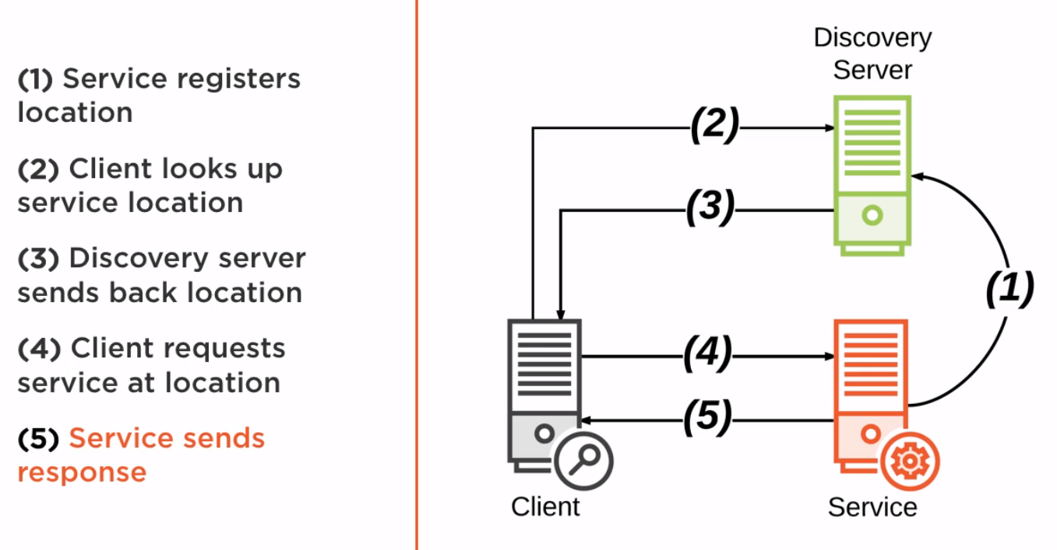

Demo : C:\Users\stkra\Documents\Spring\spring_cloud_workspace

Go to <https://start.spring.io/> and create projects for Service Discovery Server, Service and Client. Import all the 3 projects in STS through import -> Existing Maven Projects.

Discovery Server –

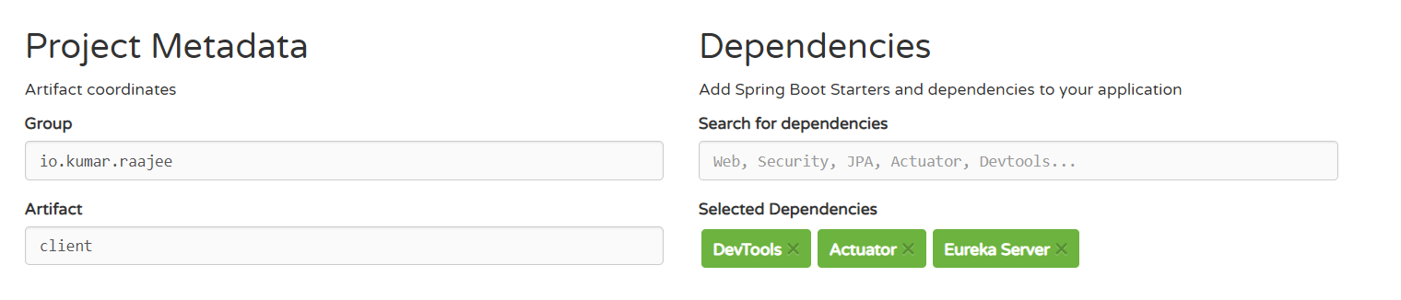

Service & Client

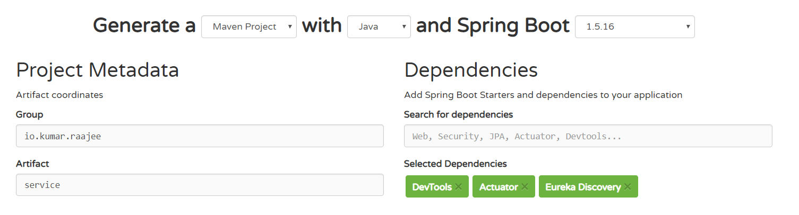

Discovery Server :

1. Open up the main application in Discovery Project and add the annotation @EnableEurekaServer
2. Open up the application .properties and add the following entries,

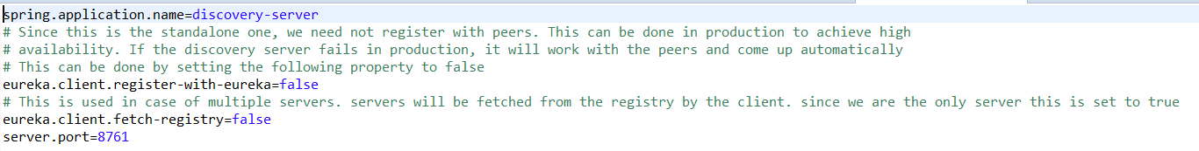

Service :

1. Open up the main application in Service Project and add the annotation @EnableDiscoveryClient[This enables the service to register itself. At the same, it can search for a service in the registry],@RestController and update the class as follows,

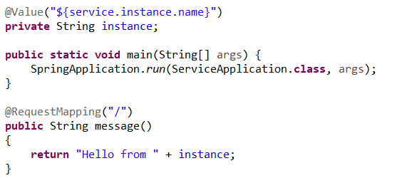

1. Open up the application .properties and add the following entries,

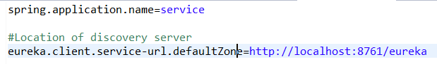

Client:

1. Open up the main application in Client Project and add the annotation @EnableDiscoveryClient,@RestController and update the class as follows,

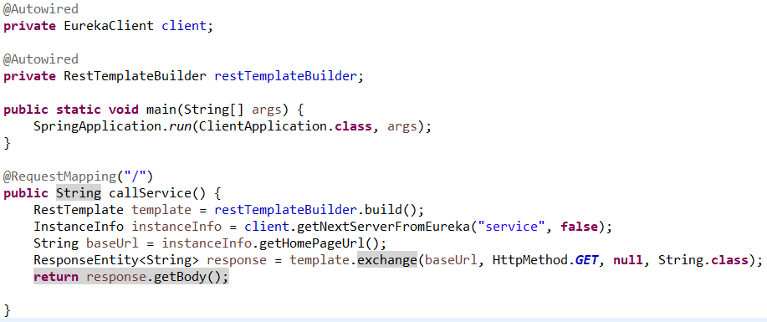

1. Open up the application .properties and add the following entries,

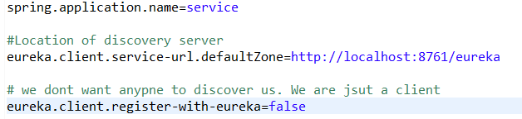

Execution :

1. Start the Discovery Server
2. You have to create 2 instances of the service through Run -> Run As Configurations and start both the instance in different ports 8081 & 8082. Provide the service.instance.name in override properties
3. Start the client
4. Go to the browser and give localhost:8080. You will get response from both the instances.
5. To go to the Spring Cloud Eureka Dashboard, go to localhost:8761

**2.Configuring services using Distributed Configuration:**

To set up the configuration for a native cloud application(distributed Application), we go for a dedicated configuration server(Spring Cloud Config Server is an implementation of Configuration Server). Spring Cloud Config provides server and client side support for externalized configuration in a distributed system.

1. Config Files accessed by HTTP REST access
2. No writing of config files. It will only serve the config files already stored
3. No need of DB to store the config files. It stores in GIT, SVN, Filesystem
4. Configuration scopes : Global, application specific, profile

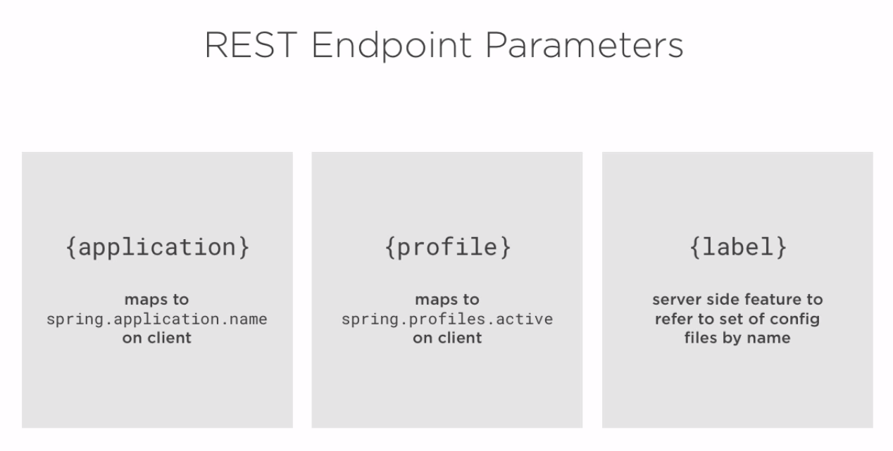

REST Endpoints:

* Get/{application}/{profile}/[{label}] – Label is optional

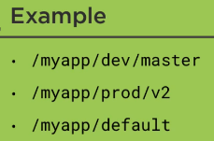

* Get/{application}-{profile}.(yml|properties)
* Get/{label}/{application}-{profile}.(yml|properties)

Demo : C:\Users\stkra\Documents\Spring\spring_cloud_config_workspace

Go to <https://start.spring.io/> and create projects for config Server. Import the project in STS through import -> Existing Maven Projects.

Config Server:

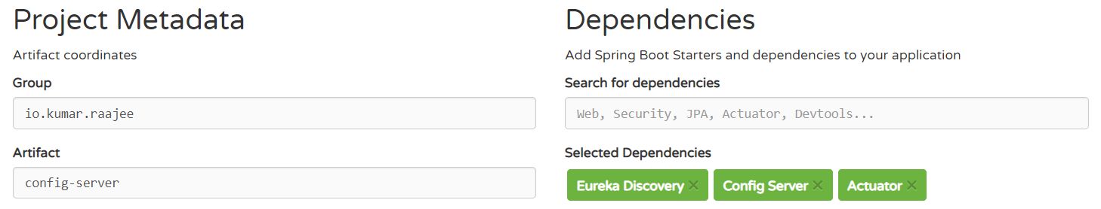

Config Client App:

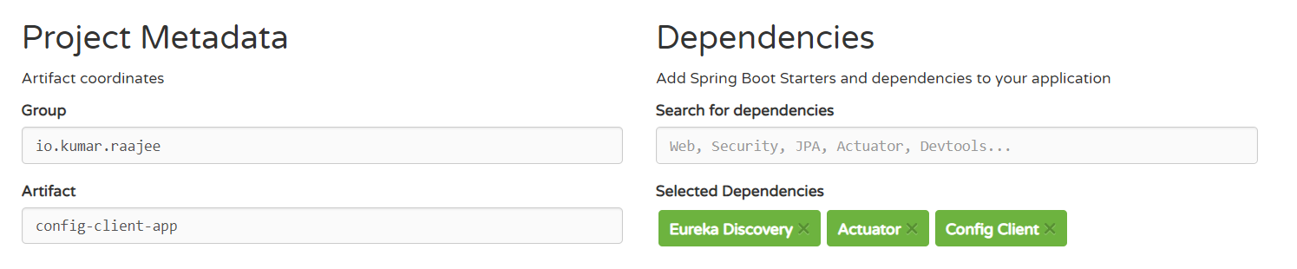

Config Server:

1. Open up the main application in Config Server Project and add the annotation @EnableConfigServer,@EnableDiscoveryClient(This enables clients to search for the config server in the discovery server)
2. Open up the application .properties and add the following entries,

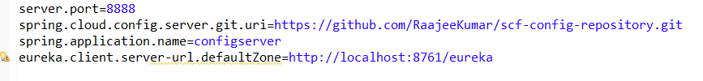

Where are the actual configurations stored.?

GIT. Go to your github account and fork dustinschultz/scf-config-repository. Copy the clone url and open up the STS GIT perspective and try to clone the url. Once its cloned, expand the folder, right click on the working tree and import maven projects. You can see the configuration files in your workspace.

Discovery server:

This is the place where the clients will look for the config server. Go to <https://github.com/dustinschultz/scf-discovery-server> and copy the clone url. Copy the clone url and open up the STS GIT perspective and try to clone the url. Once its cloned,right click on the folder and say import maven projects. You can see the Discovery server project in the workspace.

Config Client App : This will bootstrap(It has to fetch the configuration from config server before the spring context is initialized to resolve things like resolving all property placeholders).This can be done by Bootstraping with bootstrap.properties/bootstrap.yaml file

Two ways :

Config first – application name, url to configuration server

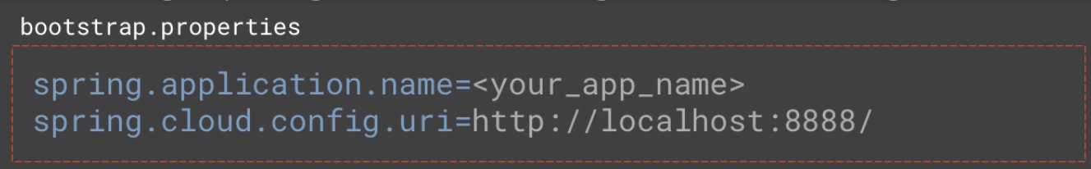

Discovery first – application name, location service discovery server

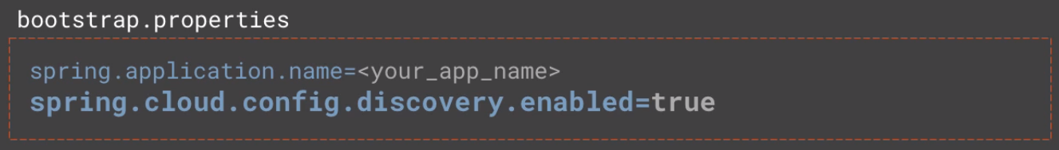

1. Open up the main application in Client Project and add the annotation @EnableDiscoveryClient,@RestController and update the class as follows,

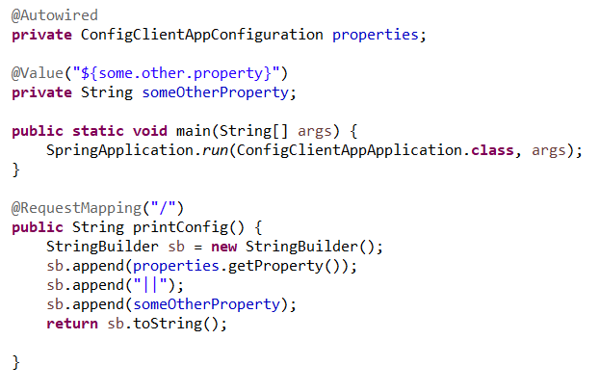

1. Open up the bootstrap .properties and add the following entries,

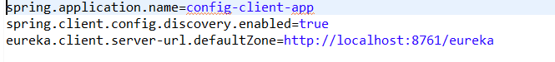

1. Create a class ConfigClientAppConfiguration

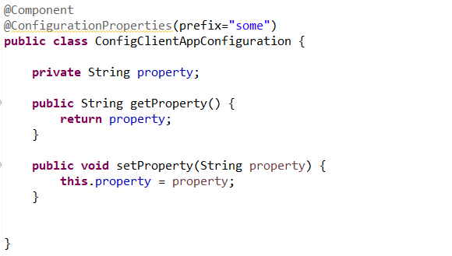

Execution :

1. Start the Discovery Server
2. Start the Config Server
3. Start the client
4. Go to the browser and give localhost:8080. You will see the properties from config server

Updating configuration at runtime :

1. Update the configuration and push it to repository.
2. Then call /refresh endpoint on actuator project.

Actuator Refresh : In postman, method = post, url =http://localhost:8888/refresh

This has to be called on all services using this configuration. Other option is to use /bus/refresh

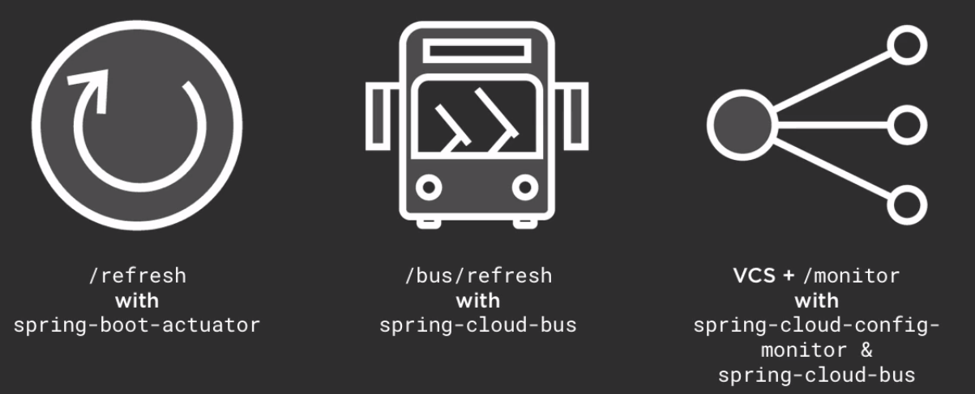

1. @RefreshScope – This is to refresh a @Bean or @Value that only gets its configuration during initialization.

**3.Mapping services using Intelligent Routing:**

Intelligent Routing – If you have multiple services in cloud with different IP, port. It will be difficult for the client to identify the services.so intelligent routing came into picture. Intelligent Routing is done through gateway. Gateway service provides the following,

* Dynamic Routing & Delivery
* Security & Filtering
* Auditing & Logging
* Request Enhancement
* Load Balancing
* Different APIs for different clients

Intelligent Routing is implemented by Netflix Zuul & Spring cloud. You can do it 2 ways. One is through Service Discovery. Other one without it. Ribbon is the load balancing in client side

Zuul allows you to intercept and control requests and responses that pass through the gateway.

Filter Types:

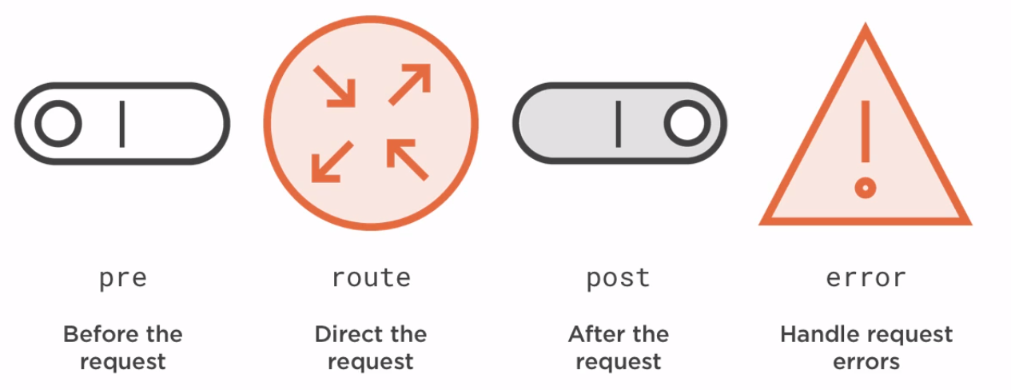

To implement Filter, extend Zuul filter and override 4 methods

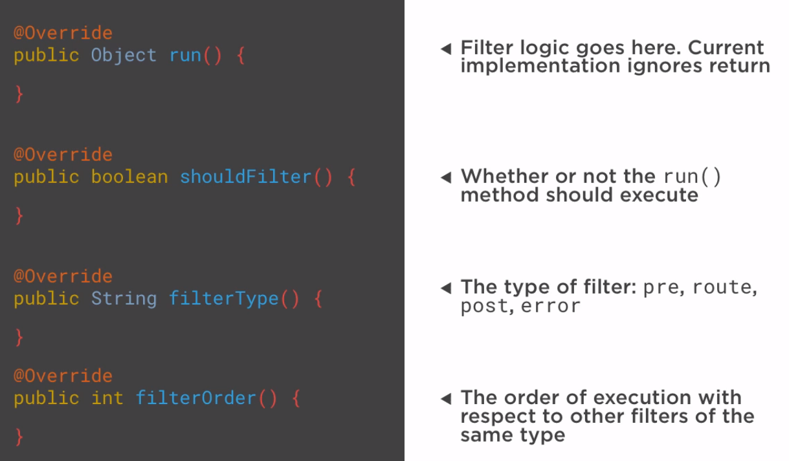

**Demo** - C:\Users\stkra\Documents\Spring\spring_cloud_routing_workspace

Discovery server:

This is the place where the clients will look for the Gateway Service. Go to <https://github.com/dustinschultz/scf-discovery-server> and copy the clone url. Right click on the package Explorer and say import -> Checkout maven projects from SCM. Provide the clone URl,you can see the Discovery server project in the workspace.

Go to <https://start.spring.io/> and create projects for config Server. Import the project in STS through import -> Existing Maven Projects.

Gateway Service:

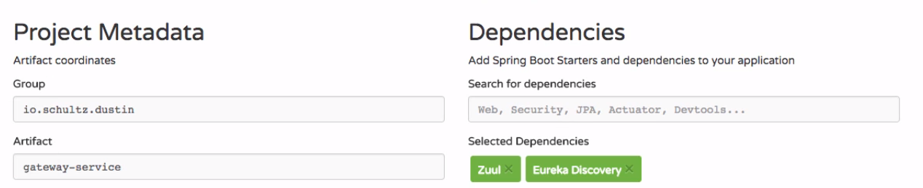

1. Main Application changes : @EnableZuulProxy turns your class to Gateway service.

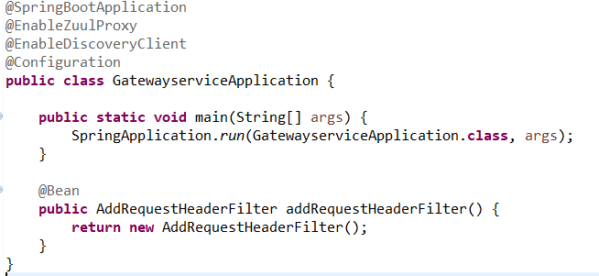

1. Application.properties



1. Filter code:

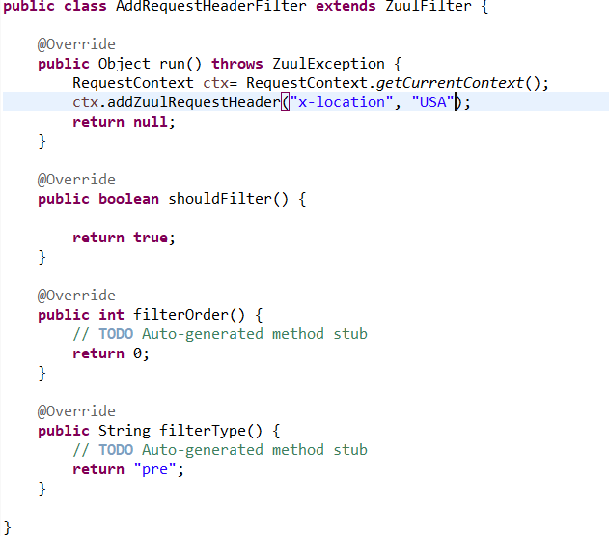

Helloservice:

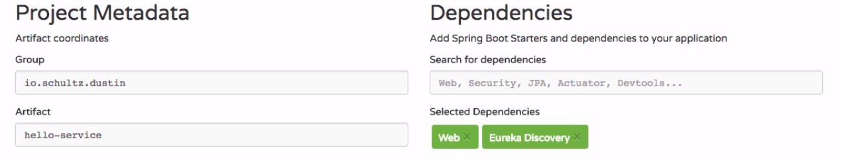

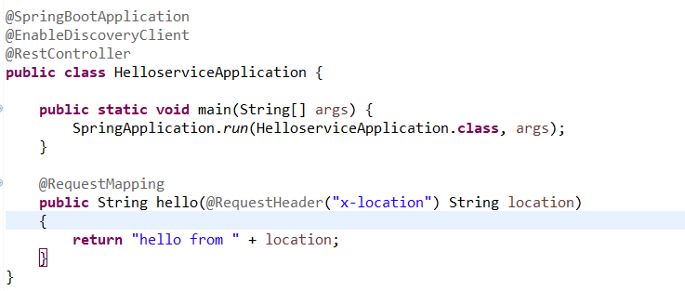

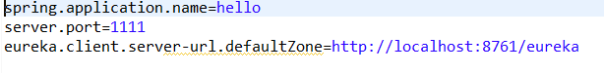

Goodbyeservice:

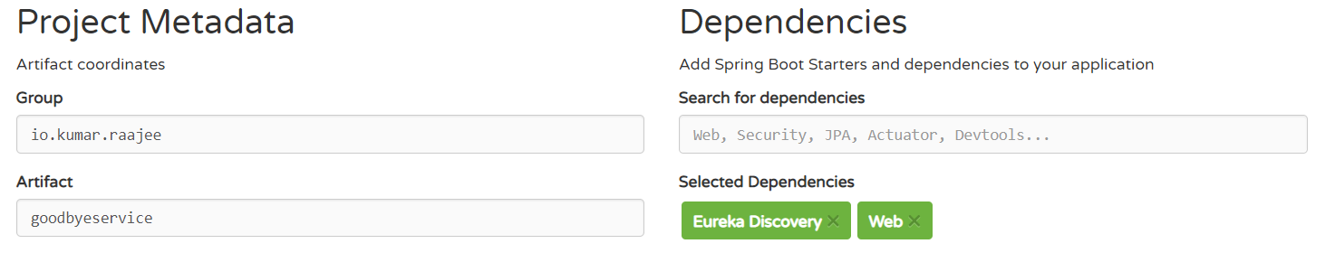

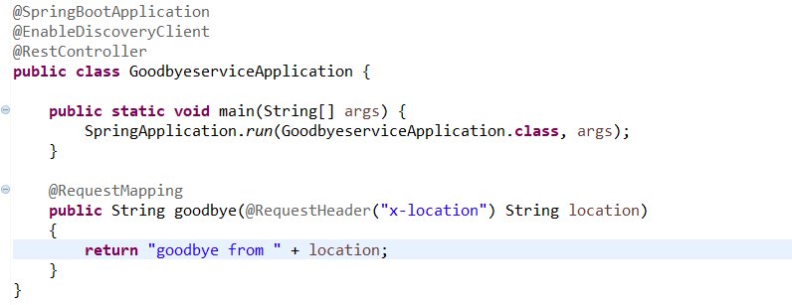

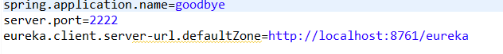

Execution :

1. Start the Discovery Server, Gateway Service, helloService, goodbyeService
2. Go to the browser and give <http://localhost:8080/goodbye>, <http://localhost:8080/hello>

You will get response from both the services. Request goes through the gateway service.

1. To go to the Spring Cloud Eureka Dashboard, go to localhost:8761

**4.Calling services using Client side Load Balancing:**

Client Load Balancing vs Serverside Load Balancing:

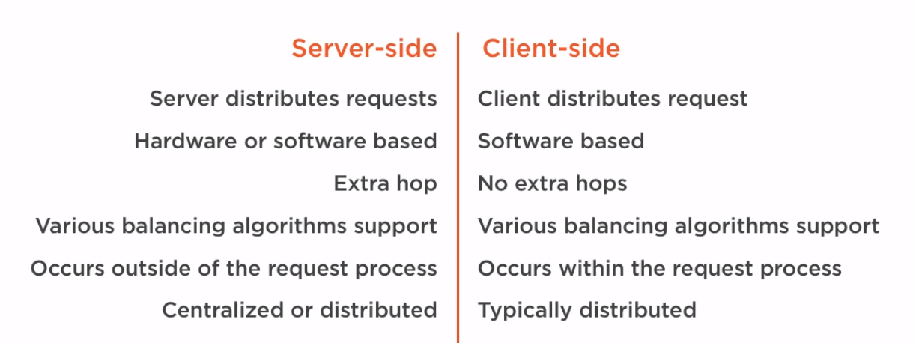

Client side Load Balancing is implemented by Netflix Ribbon + Spring cloud

@LoadBalanced – Marks a Rest template to support Load Balancing

@RibbonClient – Used for custom configuration and when service discovery is absent

Demo: C:\Users\stkra\Documents\Spring\spring_cloud_loadbalancing_workspace

Discovery server:

This is the place where the clients will look for the Gateway Service. Go to <https://github.com/dustinschultz/scf-discovery-server> and copy the clone url. Right click on the package Explorer and say import -> Checkout maven projects from SCM. Provide the clone URl,you can see the Discovery server project in the workspace.

Ribbon-time-service: Create 2 instances of this service by going to Run -> Run As Configurations

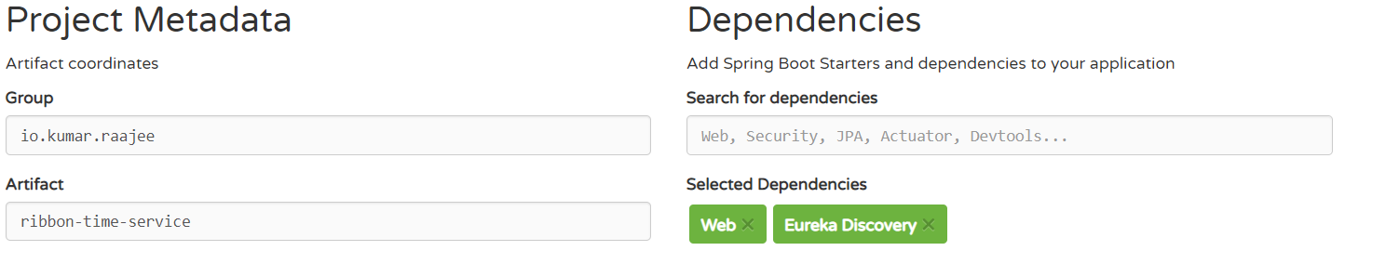

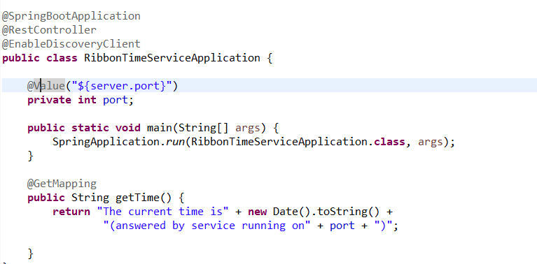



Ribbon-time-app:

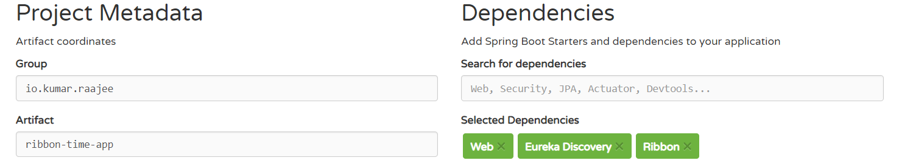

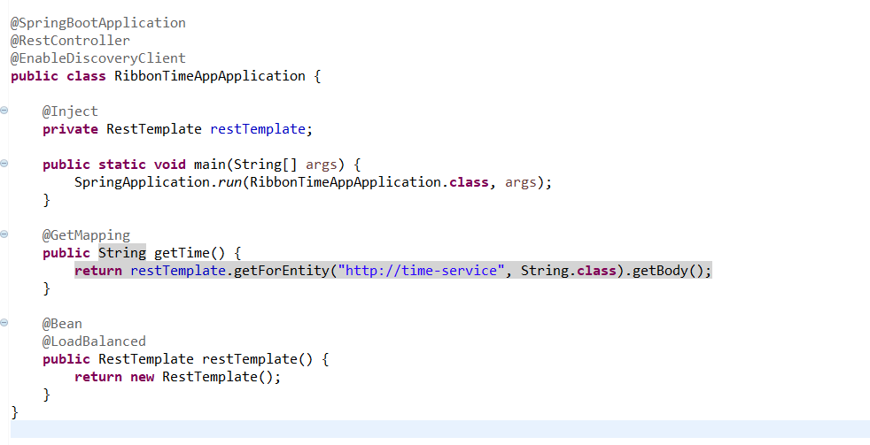

To make use of Ribbon client, In service class remove @EnableDicoveryClient. Then remove the discoveryServer Url from Service Application. Then in client app, remove @EnableDiscoveryClient & add @RibbonClient(name=<Nameof service>). Then add the entries in application.properties

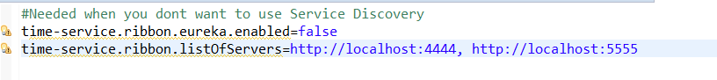

Customizing the Ribbon load balancer through a configuration class

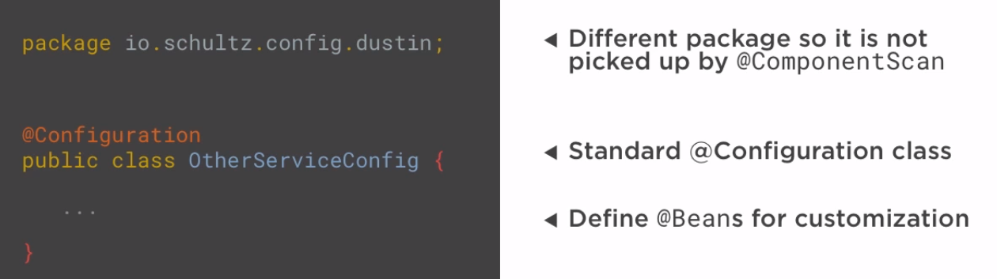

IRule Bean: control load balancing strategy that is used to distribute the load between the instances that are being load balanced

IPing Bean: choose the strategy to check the liveliness or availability of a given instance that is being load balanced

Execution :

1. Start the Discovery Server, ribbon time Service 1 , ribbon time Service 2, ribbon time app
2. Go to the browser and give <http://localhost:8080>. You will get response from both the service instances.
3. To go to the Spring Cloud Eureka Dashboard, go to localhost:8761

**5.Creating self healing services with circuit Breaker:**

Cascading Failures : Failures in one part of system causes the other part to fail.

To avoid cascading failures:

Circuit Breaker Pattern : Used to detect failures and encapsulates logic of preventing a failure to reoccur constantly

Fault Tolerance is implemented by Netflix Hystrix + Spring Cloud

Demo: C:\Users\stkra\Documents\Spring\spring_cloud_circuitbreaker_workspace

Discovery server:

This is the place where the clients will look for the Gateway Service. Go to <https://github.com/dustinschultz/scf-discovery-server> and copy the clone url. Right click on the package Explorer and say import -> Checkout maven projects from SCM. Provide the clone URl,you can see the Discovery server project in the workspace.

Weather-service:

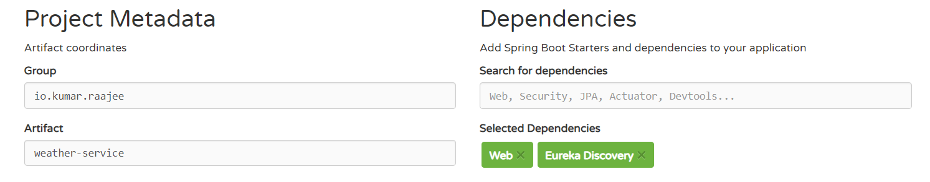

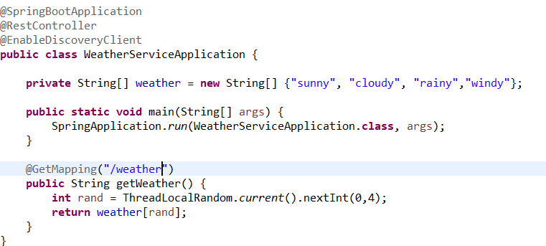

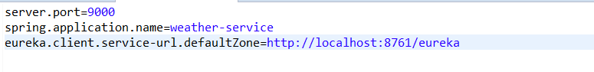

Weather-app:

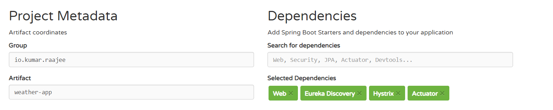

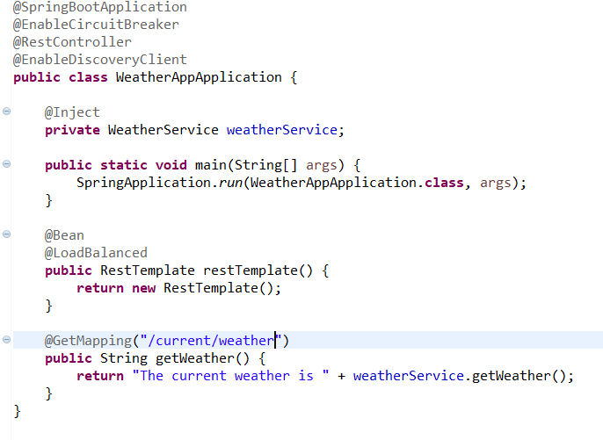

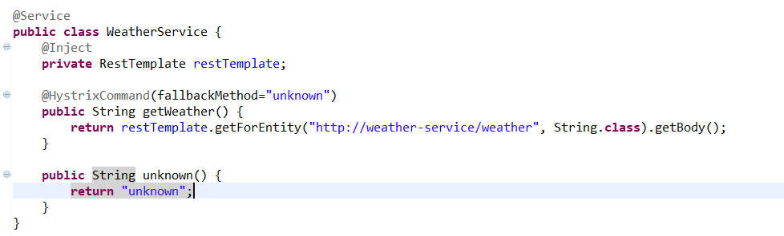

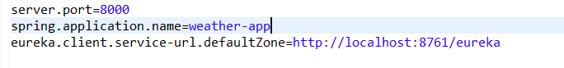

hystrix-dashboard:

Hystrix Dashboard @EnableHystrixDashboard – To enable HystrixDashboard

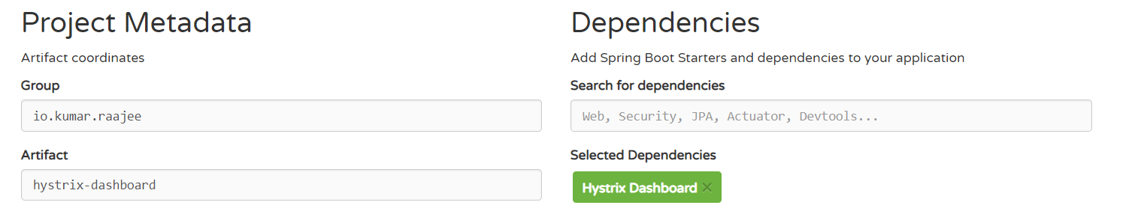

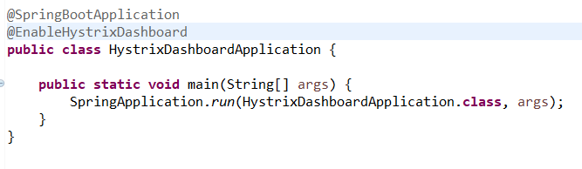

Execution :

1. Start the Discovery Server, weather Service , weather app, hystrix dashboard
2. Go to the browser and give <http://localhost:8000/current/weather>.
3. <http://localhost:8080/hystrix> for hystrix dashboard and provide this url to get the details, <http://localhost:8000/hystrix.stream>
4. To go to the Spring Cloud Eureka Dashboard, go to localhost:8761

Netflix Turbine – Aggregation of many hystrix streams to one

This is implemented by Netflix Turbine + Spring Cloud

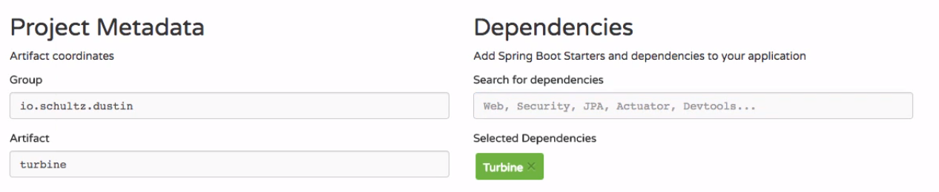

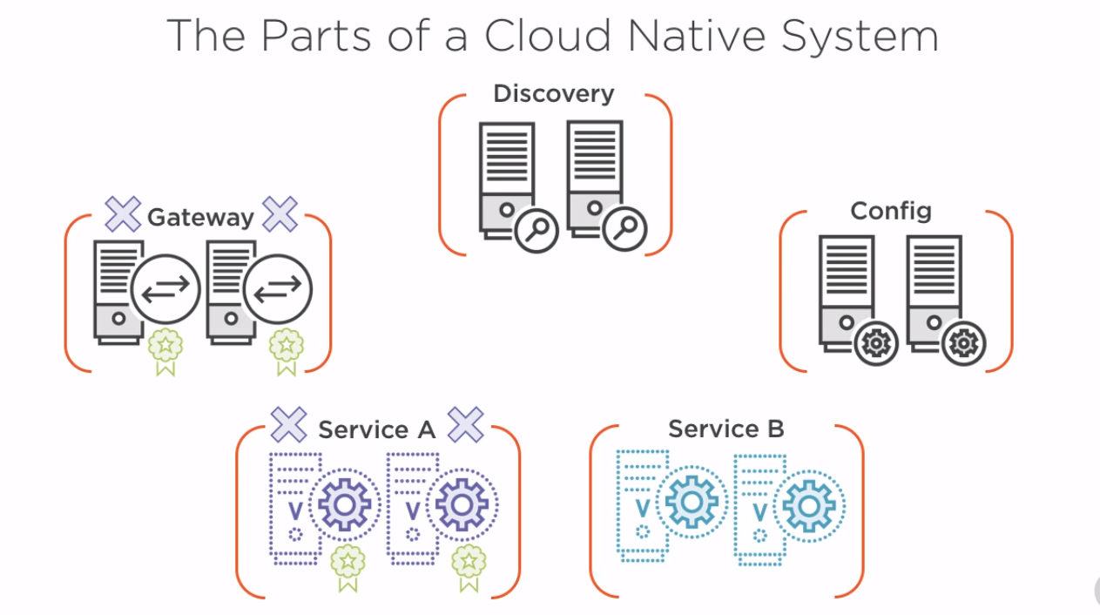

1. On start up, services, gateway & config look up at discovery to either register or look up for services
2. For services, its very important as they look up the discovery to find the config server
3. Request comes to the gateway, in our case its Netflix Zuul. Gateway will match the path to a given service id and look it up in the Discovery server.
4. Once the service is located, it will use the hystrix protected call using Ribbon to handle the client side load balancing of which instance it should send the traffic to.
5. If service A is dependent on Service B, it will look up for service B from discovery server. Once its located, it will use the hystrix protected call using Ribbon to handle the client side load balancing and call its instance and return the response to A. A inturn sends to gateway. Gateway returns to the client

**Spring AOP:**

<https://www.youtube.com/watch?v=Ft29HgsePfQ>

JARs required for AOP : aopalliance, aspectjrt,aspectjweaver. To enable AOP, use @EnableAspectJAutoProxy

Cross cutting concerns – Functions spanning multiple layers of an application

@Aspect - Cross cutting concerns(example: logging, security, transaction code etc..) are all put in a class and we call that class aspect. AOP enables us to apply the cross cutting concerns across multiple classes

Advice – what should be called or the methods that needs to be executed. Types : Before Advice, After Advice, After throwing advice, After finally advice, Around advice

Pointcut – Defines where & when. Where and where it should be called eg: @Before(“execution(public void show)”). A set of regular expression that are matched with joinpoint to determine if the advice needs to be called

Joinpoint – point during a execution of a program such as execution of a method or handling of exception

Weaving – process that links aspects with other application types or objects to create an advised object